

**Hands-On with the Modern Data Stack: Labs**

**Hands-on Workshop**

|  |  |
| --- | --- |
| Authors | David Millman, Fivetran |
| Version | 2.0 |
| Date | Sep 26, 2023 |
| Description | This Hands On Lab guides the student through the initial configuration and setup of all the labs that will be performed today.  This latest version adds the known common values, so that labs should be shorter |

# 

**Overview 3**

Prerequisites 3

Agenda 3

What you’ll learn 3

What you’ll need 3

What you'll Build 4

Using this Lab Guide 4

Parameters for labs 4

Personalizing the Lab Guide for your lab 4

**Introduction to the Tech Stack for the Lab 7**

Fivetran 7

**Structure of the Labs 9**

**Lab Instructions 11**

Handling life’s little issues 11

**Lab 0 - Let's get oriented 14**

Navigating the lab environment 14

Navigating the Snowflake environment 16

**Lab 1 - Loading files 18**

Lab 1.1 - Creating a destination 18

Lab 1.2 - Create a file connector 22

**Certification Login Test 40**

**Lab 2 - Databases - Teleport - Analytic DB as a Source 41**

2.1 - Snowflake as a Source and Target 41

2.2 Teleport and Transactional Databases as a Source 46

**Lab 3 - Logical Replication and HVA Deployments 53**

3.1 - Using Native Database Change Detection 53

3.2 - HVA Configuration 60

**APPENDIX - A - Lab 0 Files 68**

Table2.csv 68

Table3.csv 69

Table4.csv 69

# 

# Overview

This hands-on workshop will guide you through how to load an initial set of CSV files from an S3 bucket. The main goal of this lab is to achieve a simple goal, load data into Snowflake, while familiarizing the student with the lab setup.

Fivetran provides fully managed and fully automated connectors that help create data movement pipelines that automatically extract and load data from various sources. These pipelines continuously ingest and update data in the cloud destination and enable organizations to focus on their use cases for data engineering, data science, machine learning, and business intelligence.

## Prerequisites

**Nothing** is required prior to the hands-on workshop. During the workshop, you will use:

* Snowflake Account(s) Configured: the student will be given credentials to access a Snowflake account, to read the data
* Fivetran partner account: Each partner is assigned a Fivetran partner account, everyone at that partner is eligible to use this account for training.
* Snowflake Destination Setup: each partner account will have one or more configured destinations setup that will be used
* Credential Spreadsheet: a spreadsheet is configured with a unique set of names/credentials that can be used to fill out the forms and other.

## Agenda

* Quick overview of how to load CSV files from a S3 bucket
* Review of a simple connection from S3 to Snowflake
* Review of the architecture used
* Review of the data and associated metadata placed in Snowflake

## What you’ll learn

* How you can use Fivetran’s fully managed connectors to connect to 100s of sources
* How to quickly and easily create fully automated and fully managed data pipelines

## What you’ll need

* Laptop
* Internet connection with the ability to connect to AWS and Google services in the USA
* Access to the Spreadsheet of lab attendees/usernames and passwords
* 100 Fivetran Facts (Help guide for the tests :) )

## What you'll Build

* PostgreSQL Source (relational database) to Snowflake data pipeline using Fivetran for both historical sync and incremental CDC
* Queries, dashboards, and visualizations using Snowflake Snowsight

## Using this Lab Guide

This lab guide is used in conjunction with a lab spreadsheet that has unique values for each student. They can be read during the labs, or students can spend a couple of minutes replacing values in the lab document so the exercise becomes quicker.

### Parameters for labs

Many of the values for the labs are found in the associated spreadsheet, such as schema specific names. Open the lab specific spreadsheet and find your name, in this example the attendees name is David Millman found in **[CELL-C]** and **[CELL-D]**, then validate that the correct email address is in **[CELL-E]** for the same row.

**\*\*\*If you cannot find your name and/or the email address is wrong, please let the instructor know immediately.\*\*\***

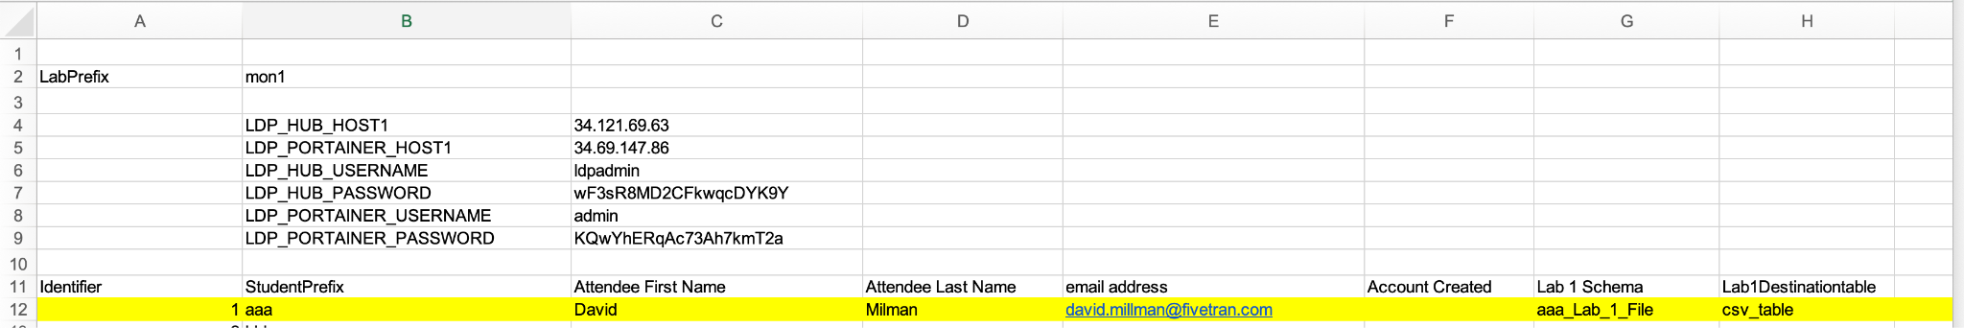

Within the labs, there will be instructions to input the value of **[CELL-G]**, the **[- ]** denote a variable value is required and **CELL-G** denotes the column on your specific row to retrieve the value. In this case the value **aaa-Lab_1_File** is copied from the spreadsheet to Fivetran.

To make this easier, it is recommended to select the row at the beginning of the lab and use the highlight formatting to distinguish ALL the unique values for you during the lab.

### Personalizing the Lab Guide for your lab

For the table below place in the Value column the value of your unique row. The first row

|  |  |  |
| --- | --- | --- |
| **Spreadsheet Cell/Description** | **Search Term** | **Value** |
| **ZZ - Test Value** | **[CELL-ZZ]** | **TestValue** |
| K - Lab Database Name | [CELL-K] |  |
| L- Worksheet Name | [CELL-L] |  |
| M - Destination Name | [CELL-M] |  |
| Q - Lab 1 Schema | [CELL-Q] |  |
| U - Snowflake Src Dest Schema | [CELL-U] |  |
| V - Postgres Teleport Dest Schema | [CELL-V] |  |
| W - Postgres Host | [CELL-W] |  |
| AB - HVA Schema | [CELL-AB] |  |
| AE - HVA Agent Host | [CELL-AE] |  |

Then for each cell value in Word perform Find and Replace, in this example, taken from the first row of the previous table, **[CELL-ZZ]** will be replaced with **TestValue** throughout the whole document by selecting **‘Replace All’**.

Repeat this step for each line in the table.

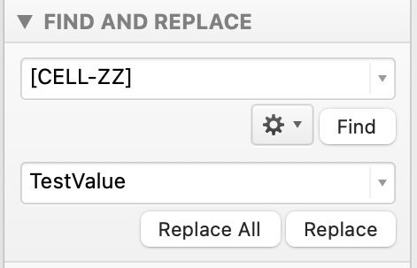

# 

# Introduction to the Tech Stack for the Lab

The labs are designed to be a realistic representation of an implementation of the Modern Data Stack (MDS). As such, a number of realistic data sources and configurations are used, with Snowflake as the cloud data warehouse. Note other destinations such as Databricks, S3-Iceberg, Google Big Query, ADLS all work in the same manner, as shown here, although with specific integrations such as with the Databricks Unity Catalog as needed. Therefore the concepts and labs demonstrated can be taken to any supported Fivetran destination.

## 

## Fivetran

[Fivetran](https://www.fivetran.com/) provides a fully managed and fully automated data movement and data integration platform that securely connects to and extracts data from all the **databases, applications, file systems, and event platforms** that drive your business while allowing you to reliably centralize data into the Snowflake data cloud.

Fivetran pipelines are no-code and are designed to continuously ingest and update data, capture all incremental changes for each source, and enable organizations to focus on their mission-critical Snowflake workloads including data warehousing, data engineering, data science, machine learning, data sharing, and data streaming. Fivetran also has a range of deployment options including pure SaaS, hybrid, and private deployment.

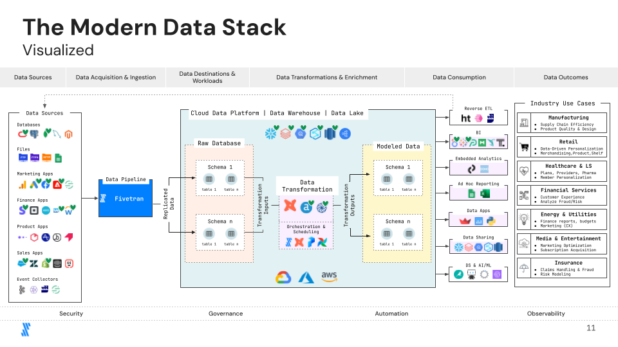

Fivetran is standard for [modern data movement](https://www.fivetran.com/data-movement) and provides the following:

* 500+ pre-built connectors which are zero maintenance and zero code
* Connectors are set up in ten minutes or less — set up the options that you need (e.g., CDC, agent, on-premises, multi-cloud, etc)
* Fully-managed/automated extract, transform, and load with 99.9% uptime
  + Automatic data updates (DML)
  + Automatic schema replication (DDL)
  + Automated recovery from failure (Idempotent)
  + Micro-batched architecture
  + Slowly changing, type 2 dimension data
  + Extensibility beyond our 500+ sources
  + Efficient writes to destination to lower compute costs
  + Plus! Accelerate time to data outcome impact and reduce data product and service (and data program) risk
* [Quickstart Data Models](https://www.fivetran.com/data-movement/transformations)
  + Use Quickstart data models to run Fivetran's pre-built data models without creating a dbt project.
  + Fivetran offers dbt Core*-compatible data models for our most popular connectors, which transform your destination data into analytics-ready datasets. Quickstart data models allows you to use these pre-built data models without building your own dbt project.

# Structure of the Labs

There are three labs associated with the certification and they fall roughly in line with the different deployment models available within Fivetran, as shown in the following diagram. Each lab demonstrates Fivetran’s ability to quickly set up a connection to initiate a historic load and an ongoing change in data capture.

The labs follow the different Fivetran deployment models and the related labs are shown here:

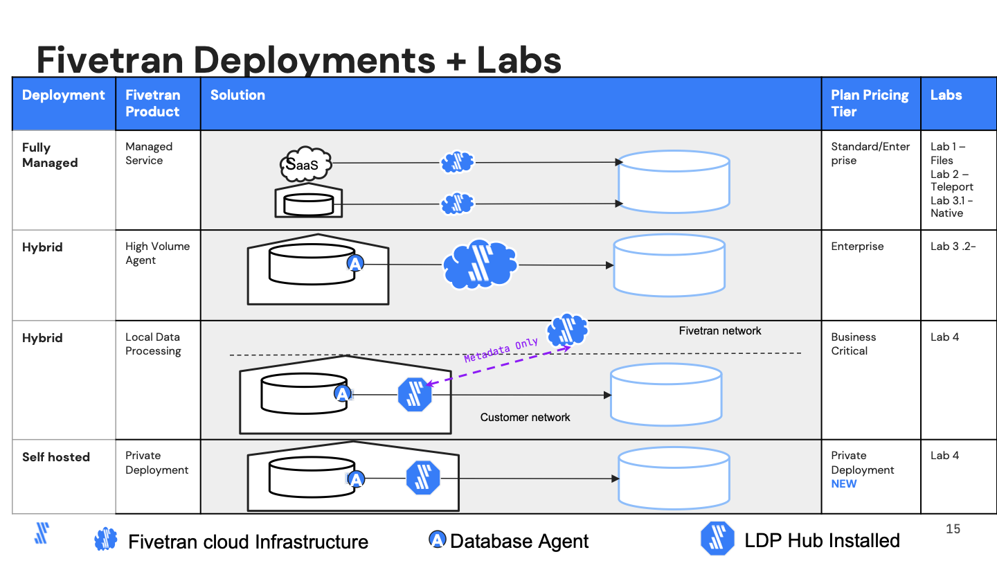

* **Lab 0 -** General orientation and confirm access to everything.
* **Lab 1 - Follow along (No Certification Test)** is designed to provide an overview of a typical scenario that Fivetran SaaS is used for, i.e. the movement of files from an external source into a cloud data warehouse (in this case Snowflake). The secondary goal of this lab is to ensure that the student has access to all the accounts, certification tools, etc. that will be needed to complete each lab certification.
  + If you have ANY issues with this lab, please let the instructor(s) know so that it can be addressed and ensure success later on in the lab.
* **Lab 2 (+ Certification Test)** is broken into two parts, this lab reviews the different options demonstrating how Fivetran’s fully managed service can quickly and easily connect to various relational databases, such as Oracle, SQL Server, MySQL, PostgreSQL, to name a few.
  + Teleport: We will utilize this logless methodology to efficiently perform a historic load and then use further SQL queries to move only changes to a specified target.
  + Database specific Logical Replication: Modern databases provide SQL-native logging solutions to determine data changes such as Change Tables in SQL Server, and LogMiner in Oracle. We will address how to configure a specific database connector with its native CDC methodology.
* **Lab 3 (+ Certification Test)** is for replicating data where the DBMS has very high data change rates. In these scenarios, SQL-based data changes will overload the DBMS causing potential application issues. This is the first lab that explains a non-SQL based approach to detect changes. Here, an agent is installed locally on the database (hybrid architecture). This agent will connect to the database through ODBC/JDBC to load historical data. Then for CDC, the agent reads the database servers’ binary transactional log minimizing the load on the DBMS and optimizing network traffic.
* **Lab 4 (+ Certification Test)** has two distinct licensing models: hybrid and self-hosted. These models utilize Fivetran LDP (Local Data Processing). This provides the ultimate flexibility and performance in terms of database setup and deployment. This lab will demonstrate a continuous data pipeline from the DBMS to Snowflake. This lab will also demonstrate LDP’s compare and repair feature.

# Lab Instructions

Prior to starting the first lab, please ensure you have access to the following:

* Login capability to your organization’s Fivetran partner account. You should’ve received an email before the lab to provide user credentials to login. If you have access to multiple accounts, please ensure that you are working in the correct one. The instructor and all other attendees will be using the same account.
* Spreadsheet or list containing all connection information. Each student has been provided a copy of a spreadsheet with lab specific values that ensure a logical tenancy since we will be working in a shared environment.
* Access to the shared Snowflake account.
* Access to Zinfi. Zinfi is the online tool that hosts the certification tests. Please login to your account at [**https://fivetran.zinfi.net**](https://fivetran.zinfi.net) and see the following certifications
  + [Certification Test 1](https://fivetran.zinfi.net/concierge/ucm/#/ucm/1298/1108/v/19) - Focused on General Fivetran Platform
  + [Certification Test 2](https://fivetran.zinfi.net/concierge/ucm/#/ucm/1298/1108/v/20) - Focused on Databases including Teleport and HVA
  + [Certification Test 3](https://fivetran.zinfi.net/concierge/ucm/#/ucm/1298/1108/v/17) - Focused on Local Data Processing (LDP) and Databases
* To help with the Certification and for knowledge beyond today, there is also a companion book ‘100 Fivetran Facts’ that will help with the tests and going forward as you start to build Fivetran solutions.

## Handling life’s little issues

No data transformation is completely smooth and there is probably a high chance that as you work through these labs, one or two things won’t work as expected. Given that there are up to 50 people attending and 2 instructors, getting round to your specific issue may take some time, so we’ve added some pointers to help.

The good news is Fivetran’s environment is very user friendly so will typically highlight potential issues, through the User Interface.

1. If the value is being copied from the spreadsheet, double check that all the values are in the correct place and you are NOT using someone else’s value
2. Ensure you are only copying the single value each time
3. Below shows a few common errors and resolutions (if the warning is presented). Error handling tables are highlighted with a RED border and will consist of a description of the potential error(s), a related screenshot/error message, a hint/clue as to what could’ve caused the issue, and a possible resolution.

|  |
| --- |
| **Managing Errors** |
| Two types of errors typically occur at this stage, the first is a duplication of configuration, normally associated with not copying the correct cell in the spreadsheet. This is highlighted, in the top right corner the error will appear such as “Sorry, we have had an unexpected Issue”. Expanding the error box as shown below will describe the problem. In this example there is already a configured destination with the same **Destination Schema** and **Destination Table** name |
|  |
| A second type of error can be observed, when the entered information does not match what is required for the destination, this results in the following style of error. Here the error “Unable to connect to bucket” is shown, in this example this is because the value in the Bucket field is “**djmtestbucket**” NOT “**djmtestbucketv2**”**.** The specified bucket either does not exist, or the user does NOT have permissions/setup to access it properly. |
|  |

# Lab 0 - Let's get oriented

This lab is designed to allow the attendee to confirm that they can login to the appropriate Fivetran.com account as well as access the Snowflake environment that will be used as part of all the labs.

There are three accounts you need:

If at any point you are unaware of how to access/follow-on please raise your hand, and we will help you with the setup.

## Navigating the lab environment

Each attendee that registered for this workshop should’ve received an email from Fivetran.com and been made an administrator of the account. This is a partner account that each attendee can use to test, develop and practice their own pipelines. It is NOT intended for use at a customer account.

If an account is required for a particular customer, such as a proof of concept, please feel free to reach out to your partner manager.

If you have not received an email, or do not have access to the partner account, please let the instructor know [**NOTE email will arrive from notifications@fivetran.com]**.

1. Goto [www.fivetran.com](http://www.fivetran.com) and select Login
2. Select ‘Log In’ on the top right of the screen, as shown on the following image.

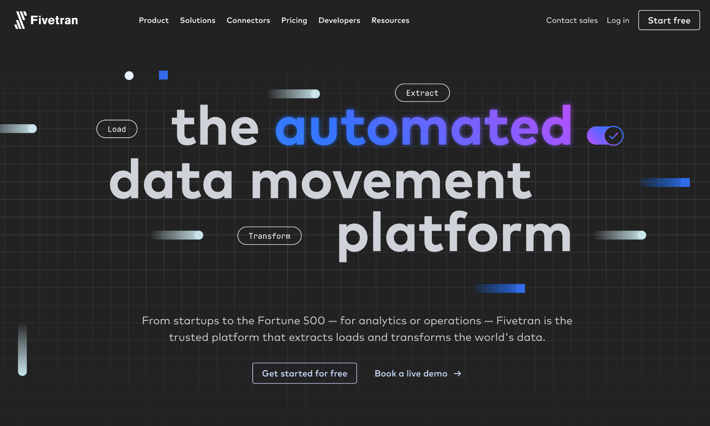

1. On successful login to Fivetran, the list of currently deployed connectors will be shown, this will be similar (but NOT identical) to the picture below.

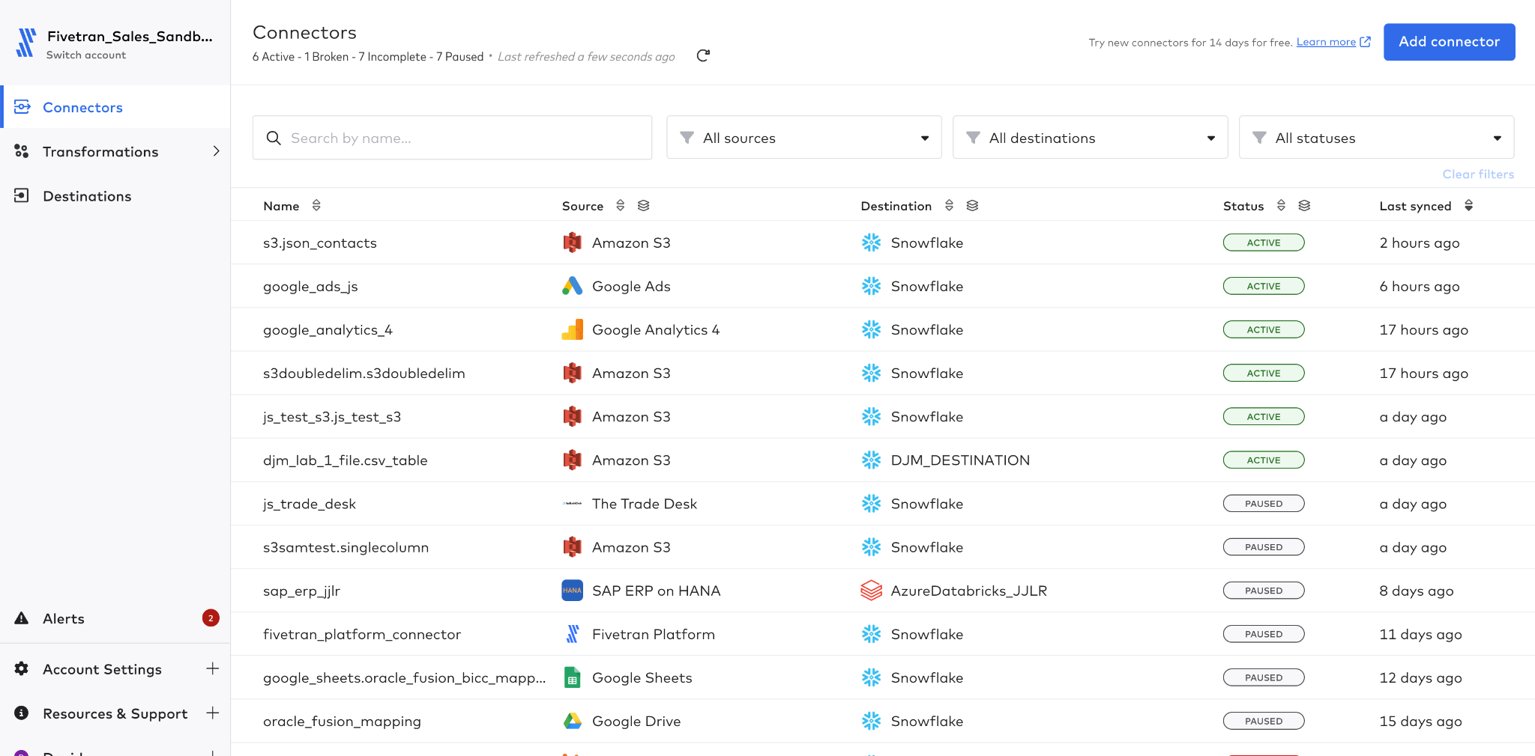

1. At this point the instructor will guide the class through the structure of the Fivetran account, this will include:
   1. Connector Overview - list of all connectors that are deployed
   2. Destination Overview - here a list of deployed destinations will be reviewed, including the available destinations
      1. Note, each student will create their own destination in the first lab.
2. On the left side navigation, the following are reviewed:
   1. Account Settings - General :
   2. Account Settings - Downloads
   3. Account Settings - Users and Permissions
   4. Account Settings - Billing and Usage
3. Resources and Support
   1. Support
   2. Documentation
   3. Release Notes
   4. Status
4. Username
   1. User Settings
   2. Notifications
   3. API Key
   4. Privacy
   5. Logout

## Navigating the Snowflake environment

Each student that is registered for this lab has access to a provisioned Snowflake lab environment.

1. In Chrome or a Snowflake supported browser, open the URL <http://fivetran.snowflakecomputing.com>
2. Enter your assigned credentials:
   1. Username **hol_user**
   2. Password **gojMjrpwWFzjYeKbVmRw**

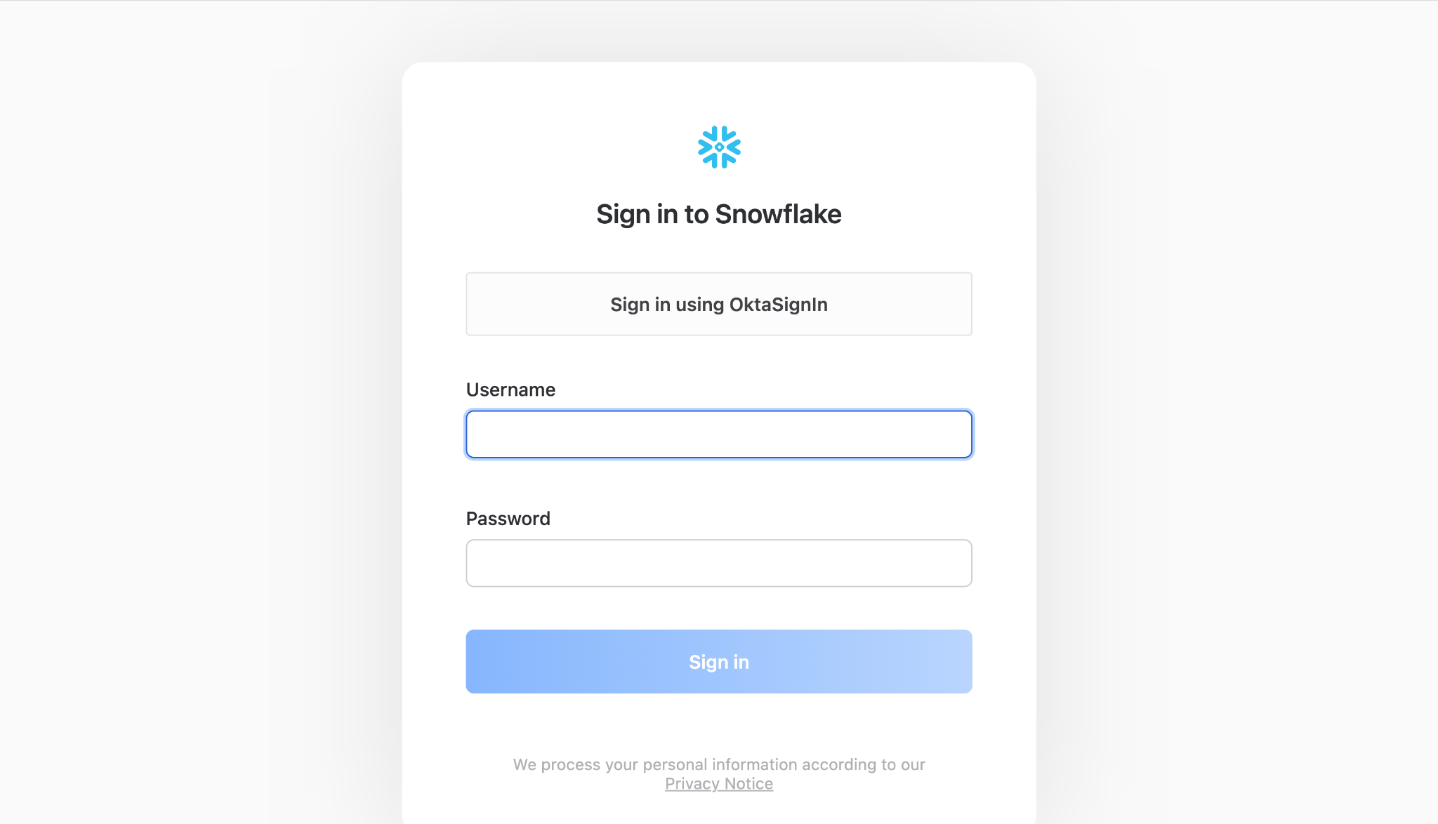

1. Press the blue ‘**Sign in**’ button. (DO NOT use the “Sign in using OktaSignin” button.)
2. On successful login, the user is presented with a screen similar to the following one.

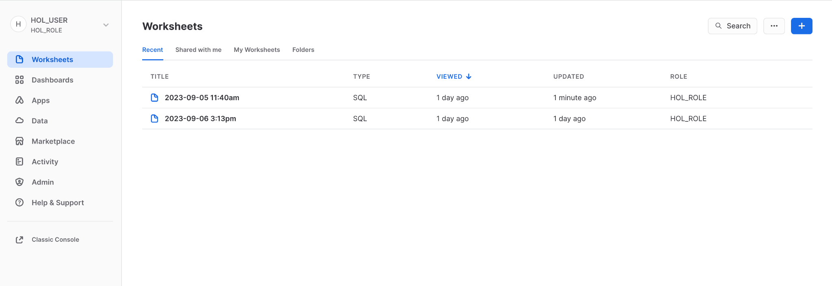

1. For this workshop there are two areas that you will need to navigate:
   1. ‘Worksheets’ - for executing SQL from this guide
   2. ‘Data’ - for viewing object definitions and sample data
2. Select ‘Data’, then ‘Databases’. Your specific database is: **[CELL-K]**

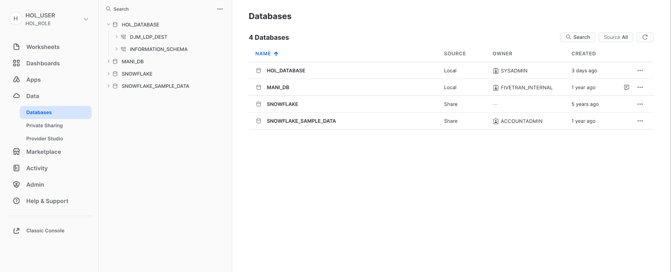

**CONGRATULATIONS - if you have reached this point with no questions or errors, you are good to go!!!!!!!!!**

# 

# Lab 1 - Loading files

For all the investments organizations have made in databases, applications, etc., a lot of data internally and externally is to be found in files. The most prevalent forms are Excel and CSV files, both of which can be loaded by Fivetran[1]. Furthermore, as open file standards have evolved, formats such as AVRO, Parquet, and JSON have been created to store and move data in terms of APIs. Fivetran has the ability to move this data in a couple of clicks.

In this lab the student will load a number of CSV files from an S3 bucket named:

**s3://djmtestbucketv2/csv/**

To perform this task the following steps are required:

1. Create a destination that will be used for this and all other labs that do not use LDP.
2. Create a file connector that writes to the destination.

## Lab 1.1 - Creating a destination

1. Open Fivetran and on the left side navigation bar, select **‘Destinations’**. The screen will look similar to the following.

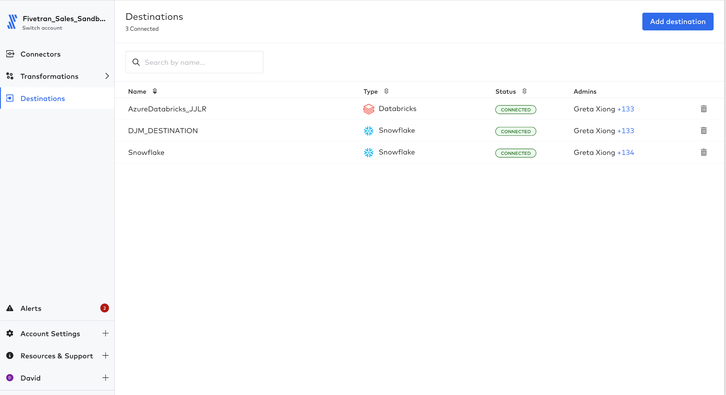

1. Press the ‘**Add destination**’ button at the top right of the screen. This will prompt for the ‘Destination name’. Use **[CELL-M]** for the destination name.

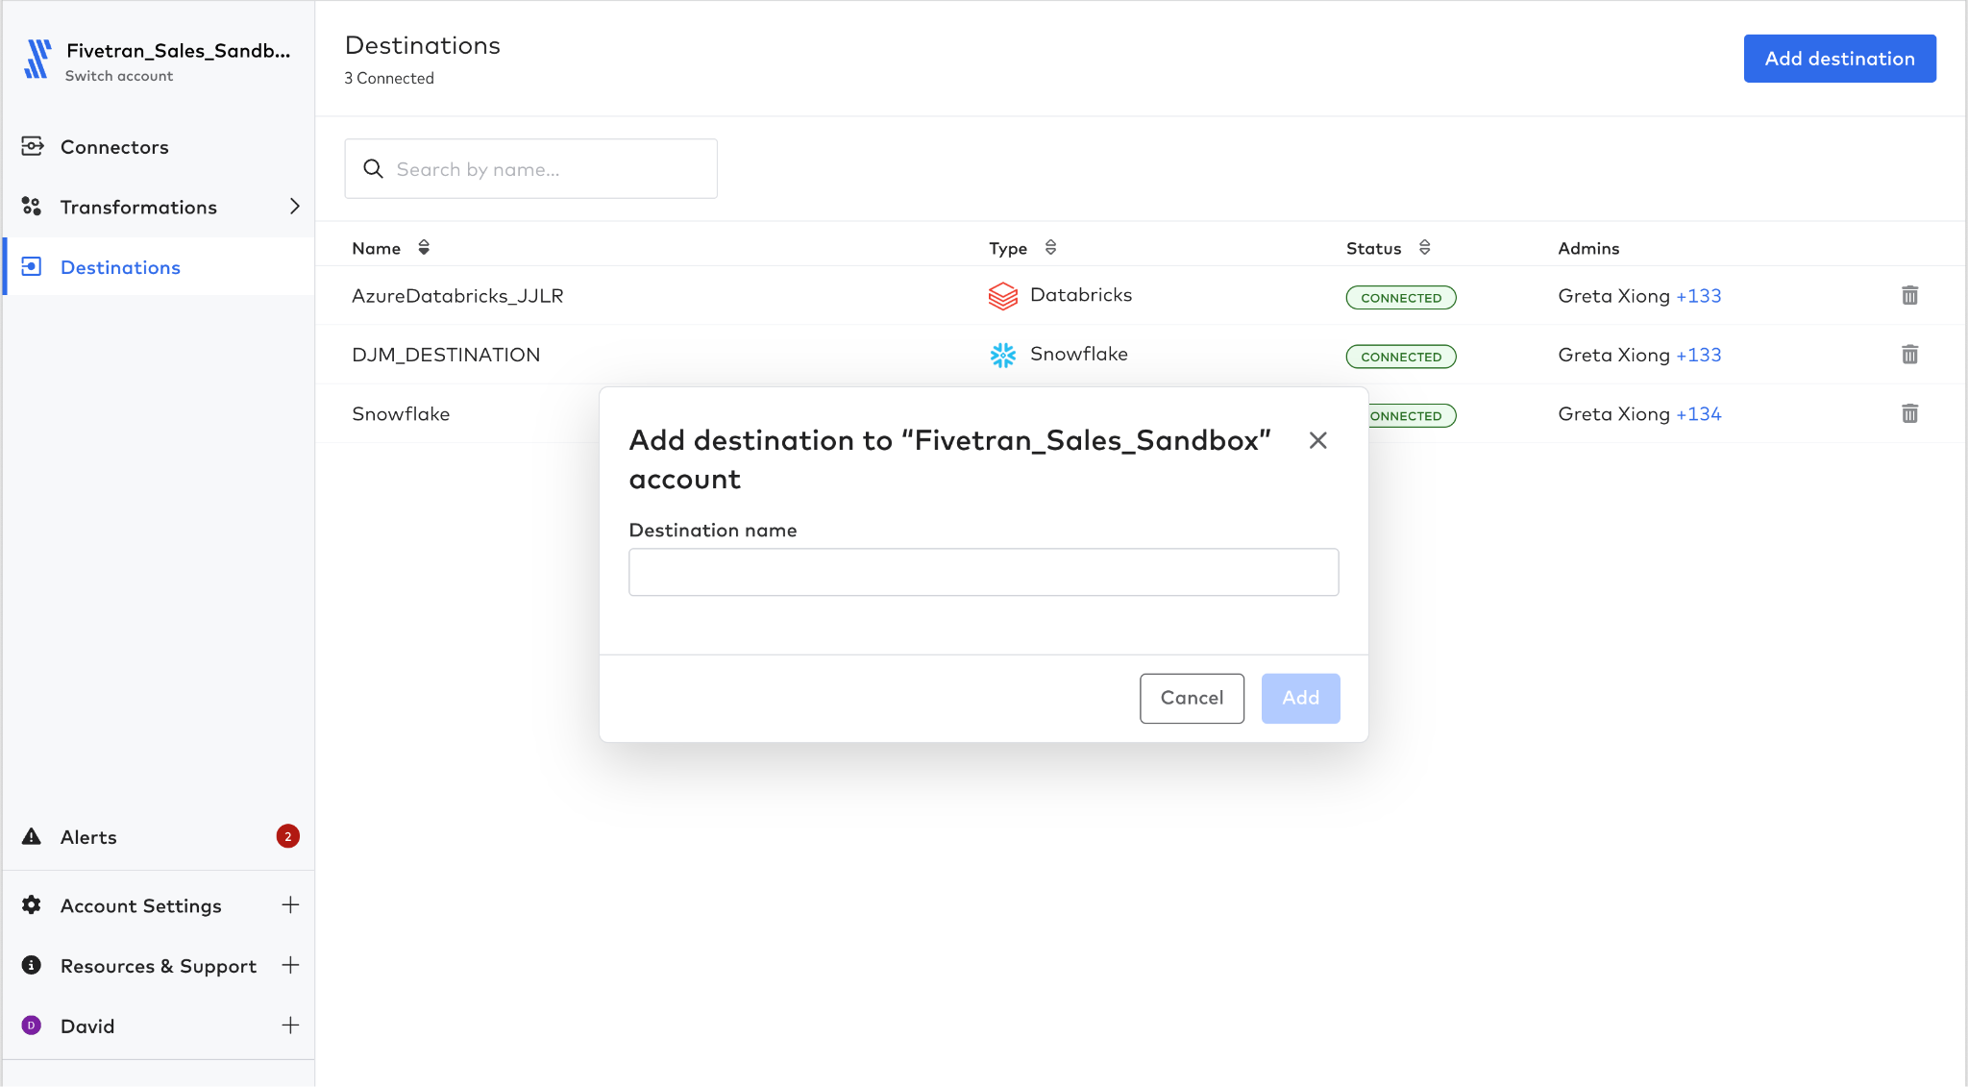

1. Select ‘Snowflake’ from the destination type list.
   1. Note the different types of analytic destinations that are available, include cloud data warehouses such as BigQuery, Snowflake, data-lakes such as Databricks, Amazon S3 (Iceberg table formats), ADLS (Delta-Lake) as well as traditional databases such as SQL Server, PostgreSQL, etc., and finally event-based destinations such as Kafka.

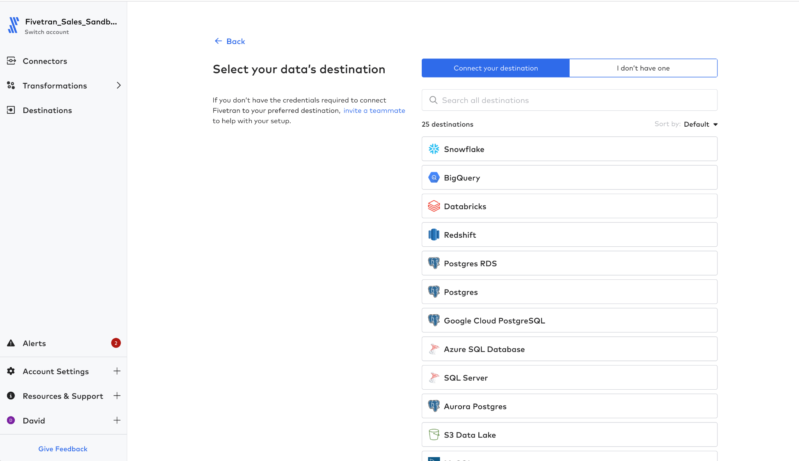

1. The destination configuration page is shown next.
   1. On the right hand side, as with all connectors and destinations, is the setup guide. The setup guide explains in detail what is needed to complete the setup of the specific destination type. For instance if you review **Step 2** in the setup guide, it shows a script that would need to be executed within Snowflake to give the Fivetran user all the required privileges. For this lab, all the setup has been performed for you, but if you are using a trial account these steps will need to be performed. Obviously for other destinations, such as Databricks, there would be similar but specific actions to perform.
   2. In the middle portion of the screen contains the setup form. Set the following:

|  |  |
| --- | --- |
| Host | **fivetran.snowflakecomputing.com** |
| Port | **443** |
| User | **hol_user** |
| Database | **[CELL-K]** |
| Auth | **PASSWORD** |
| Password | **gojMjrpwWFzjYeKbVmRw** |
| Role | **hol_role** |

* 1. DO NOT CHANGE the following
     1. **Data Processing** - this is the default processing location, this should be set at a region that is close to the destination region for performance or privacy reasons, such as GDPR, CCPA etc.
     2. **Cloud Service Provider** - Fivetran instantiates the pipeline in a specific cloud provider if needed, the default is GCP. This might make a difference for security/performance reasons.
     3. **Time Zone** - the time zone that will be used for reporting
     4. **Daylight Savings (DS)** - if this should be observed i.e. for a state outside of Arizona, or for reporting reasons. (US only)

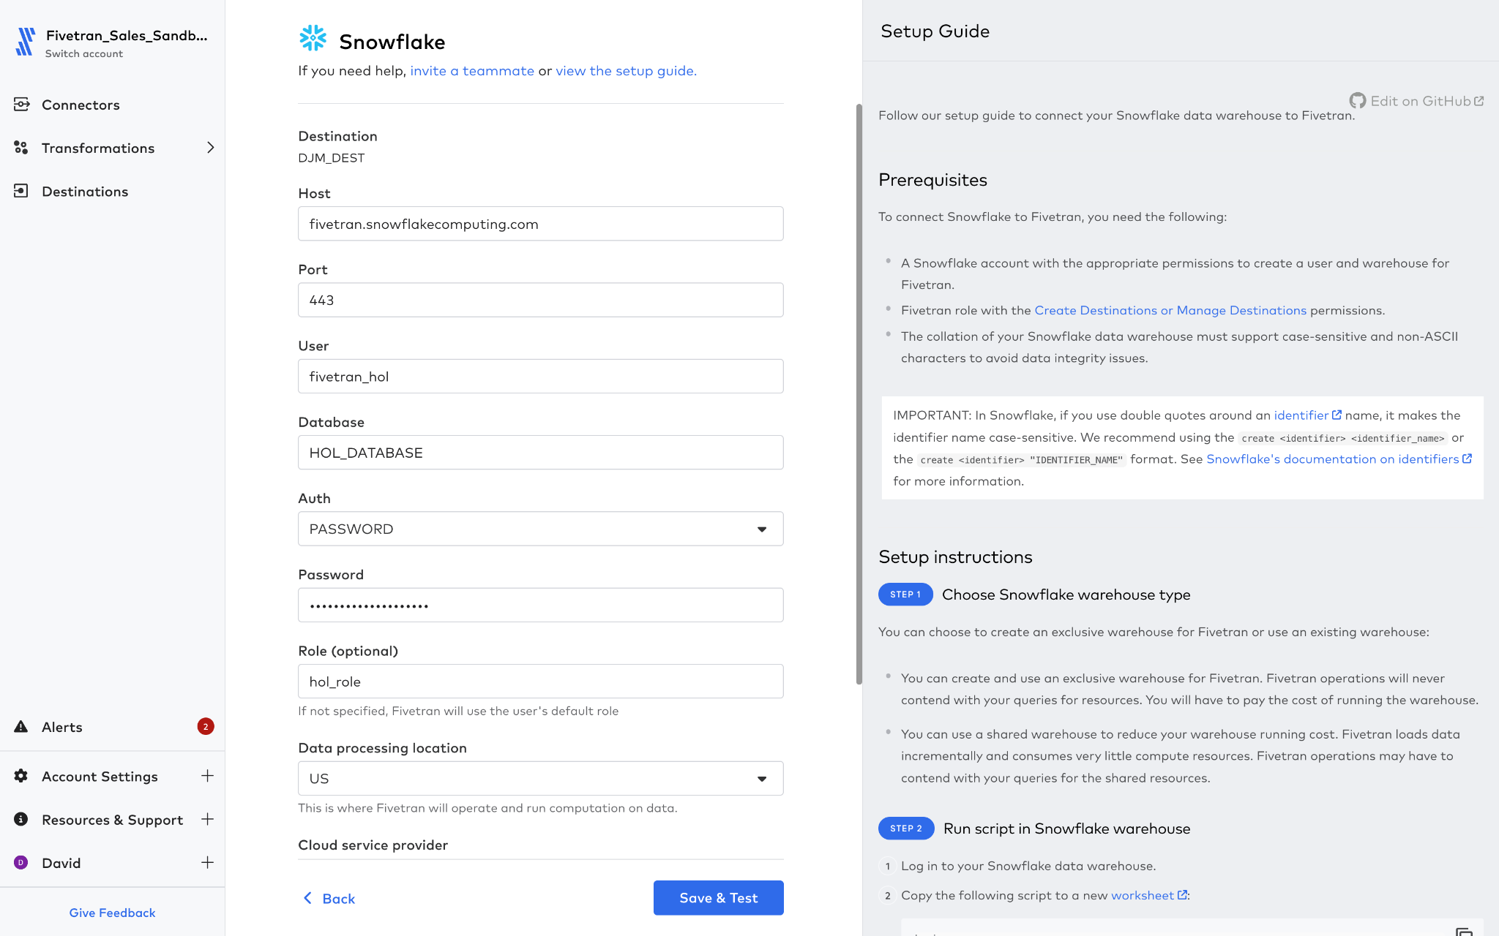

|  |  |
| --- | --- |
|  | Connection errors appear at the top of the configuration form, with a general error message ‘Connection tests failed’ and the next line will normally indicate the problem, i.e in this case Fivetran could not authenticate with Snowflake because the username or password was incorrect. |

1. Click the ‘Save & Test’ button. Fivetran runs a series of tests to ensure the Snowflake destination is configured properly. If the ‘All connection tests passed!’ message appears as shown next, all is good for the rest of the exercises.

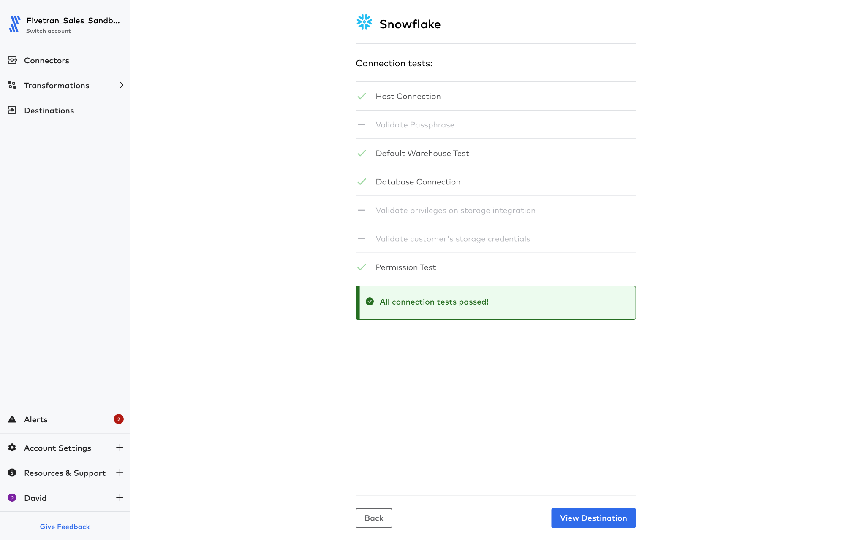

1. Click the ‘**View Destination**’ button to get a read only view of the configured destination. We now have a repository for our connectors to replicate data.

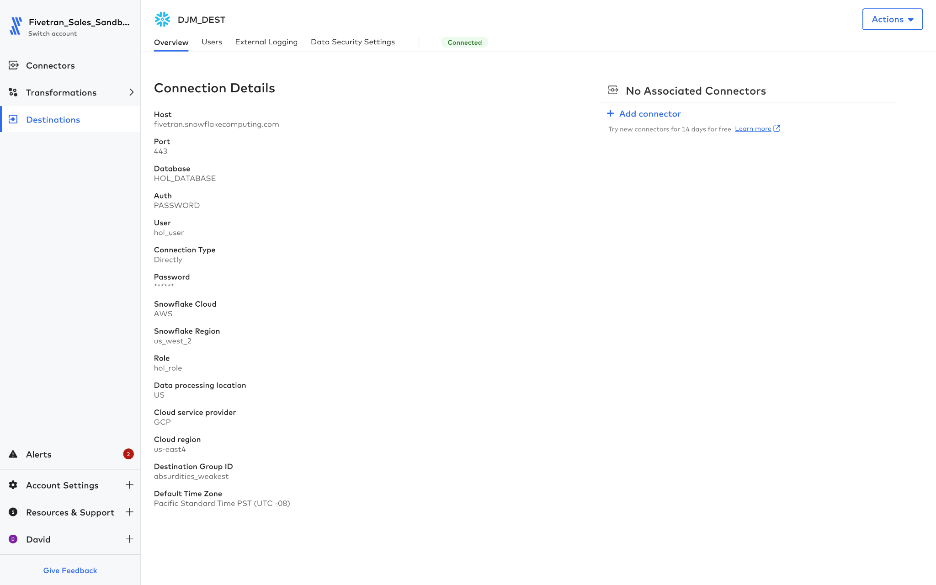

## Lab 1.2 - Create a file connector

For the destination created in Lab 1.1 - Creating a destination, any number of source connectors can be added. Our first connector will be the ‘Amazon S3’ connector.

1. In the Fivetran UI, select ‘Connectors’ in the navbar.
2. Select ‘Add connector’ at the top right of the screen.

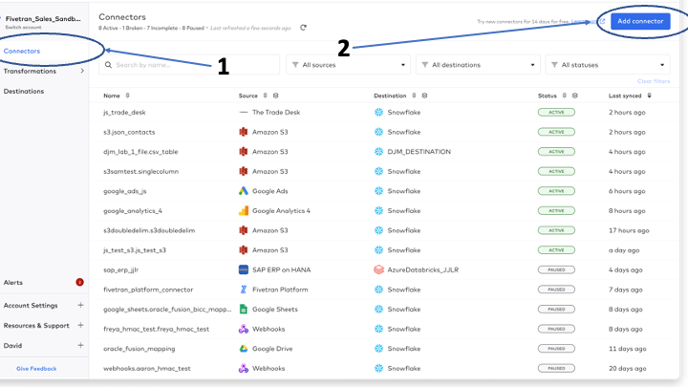

1. The list of available destinations are now displayed. Select “your” destination from Lab 1.1 - Creating a destination**,** or **[CELL-M]**

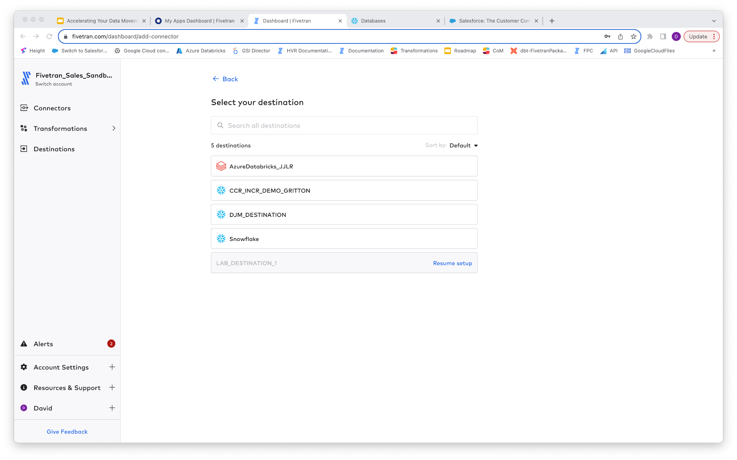

1. Next we are presented with the connector selection screen.

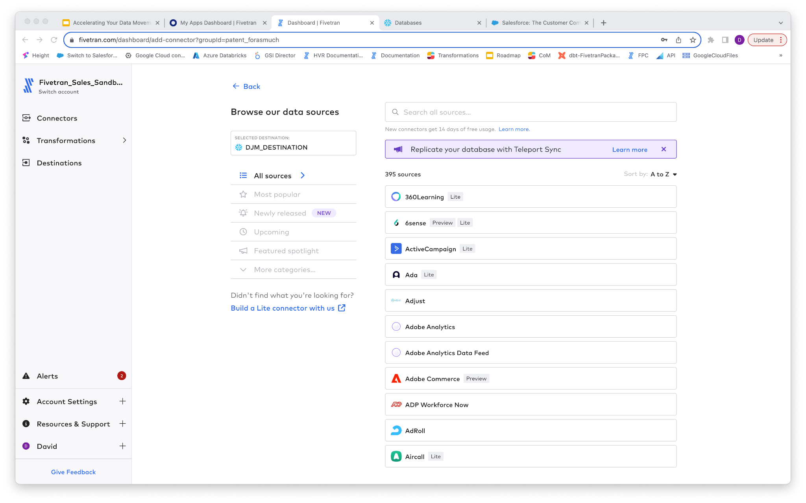

1. Select ‘All sources’. How does the number compare to that shown in the image in this lab? Can you explain the difference?
2. Let’s review some of the connectors available, ie. SQL Server.

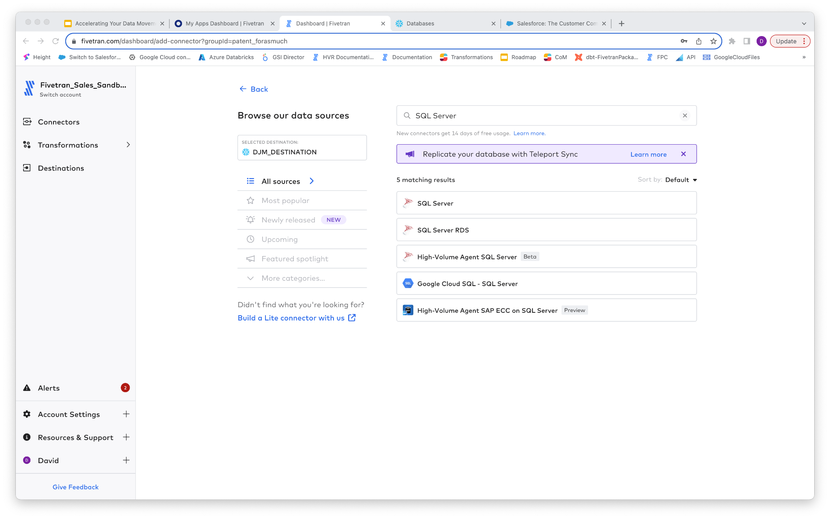

1. For Oracle connectors:

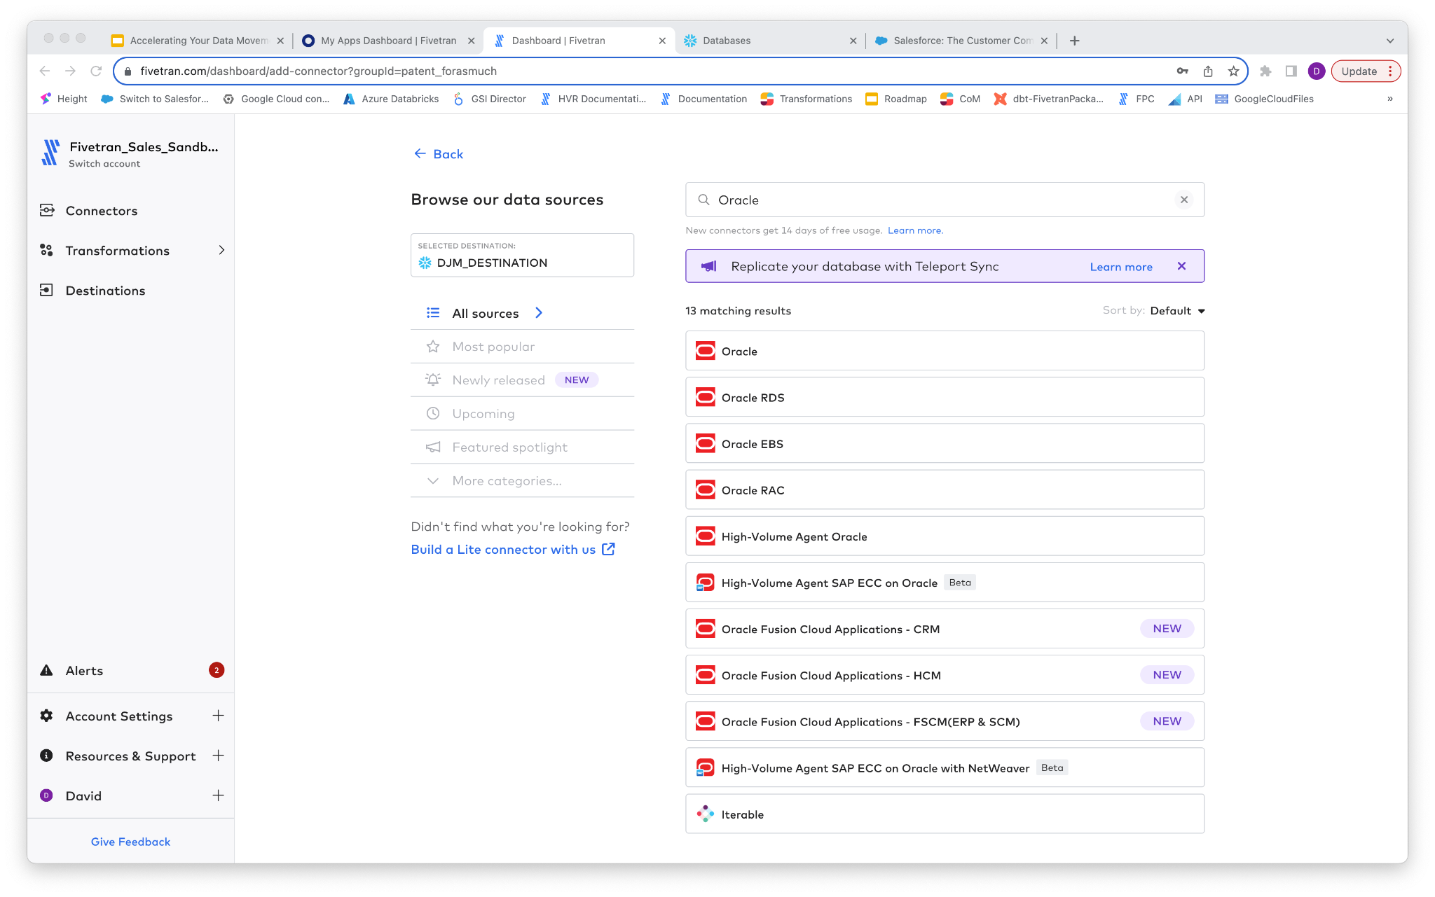

1. For SAP connectors:

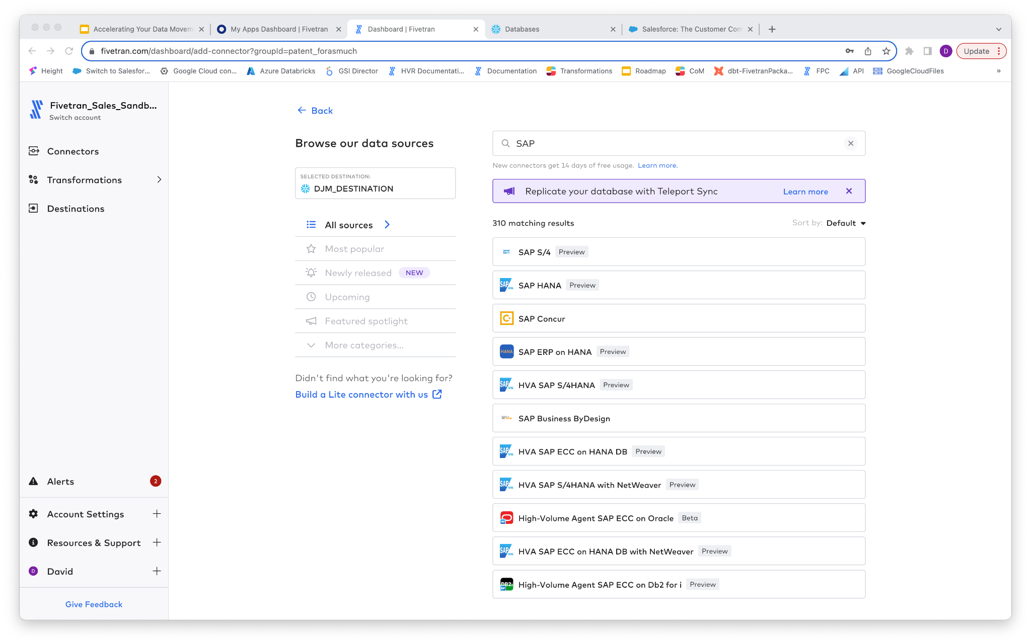\\]

1. Now it is time to create the connector for Amazon S3. In the search box, type in S3 and the Amazon S3 connector will be displayed. Hover over the ‘Amazon S3’ item in the list, and click the ‘Set up’ button.
   1. Note, selecting ‘More info’ will direct you to the documentation about the connector.

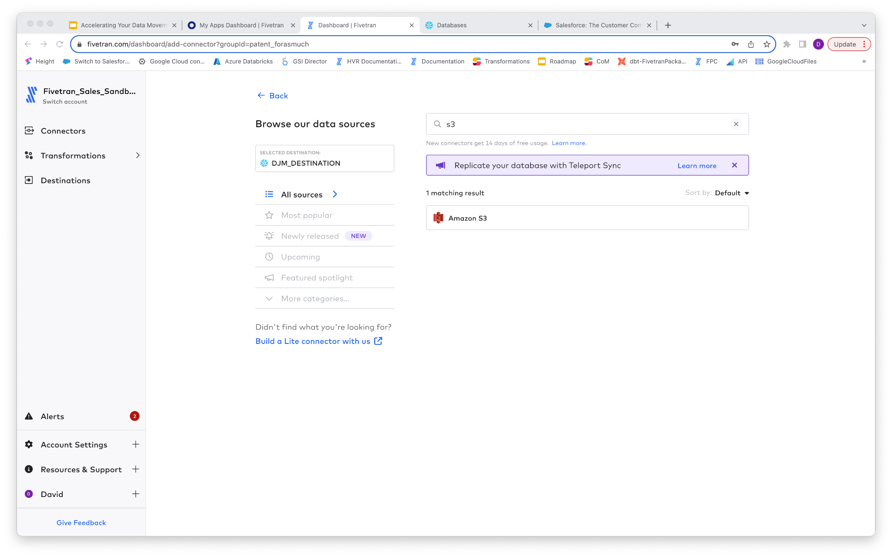

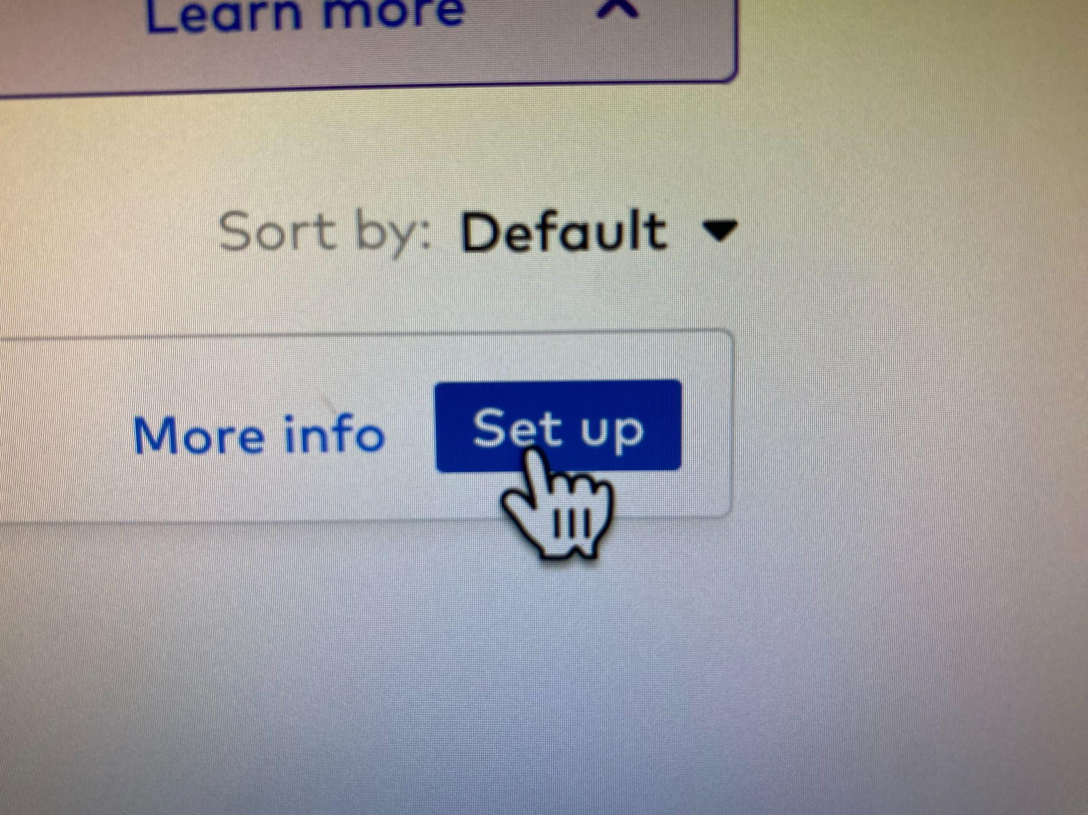

1. Enter the following into the configuration section:

|  |  |
| --- | --- |
| Destination Schema | **[CELL-Q]** l5ar_Lab_1_File |
| Destination Table | **CSV_TABLE** |
| Bucket | **djmtestbucketv2** |
| Access Approach | **Public** |
| Folder Path | **csv** |

1. The following image shows a sample:

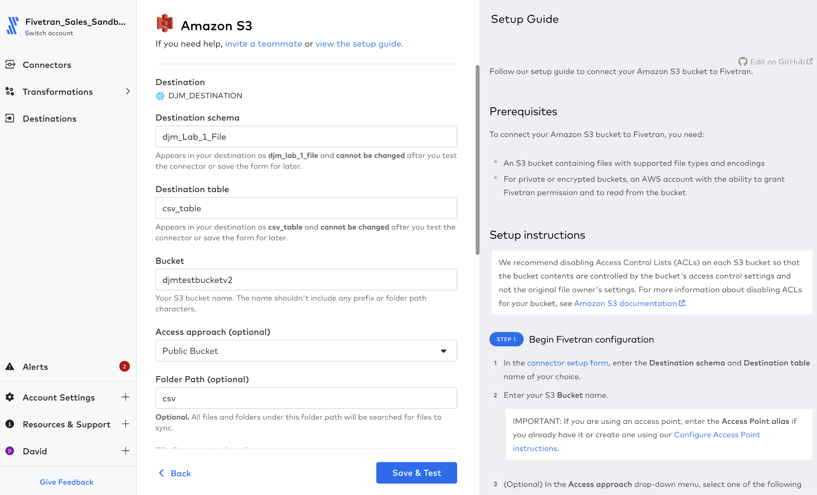

1. Click the ‘Save & Test’ button. Note that only the tests that are needed for Amazon S3, such as ‘Validating Bucket Name’, ‘Connecting to bucket’, and ‘Finding matching files’ will appear with a green tick next to them. The other tests such as ‘Validating ExternalID’, ‘Validating the pattern regex’, ‘Validating archive pattern’ and ‘validating escapeChar’ are not performed for these files, as the appropriate configuration was not defined as part of the connection.

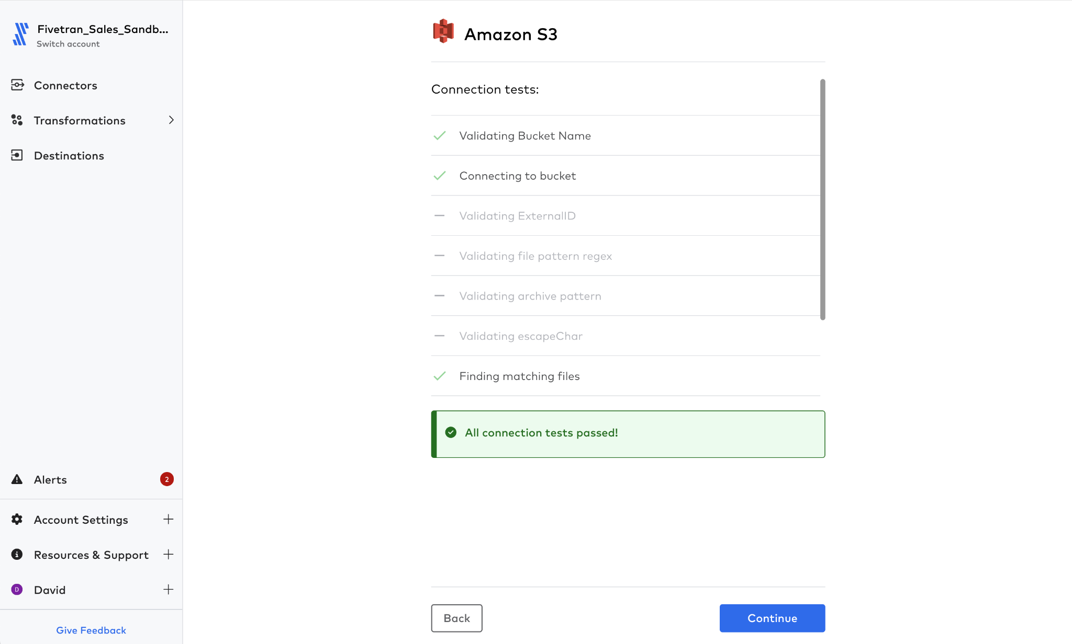

1. If the green ‘All connection tests passed!” statement appears in the ‘Connection tests’ screen as shown above, the pipeline is ready to be configured and select ‘**Continue**’.

|  |
| --- |
| **Managing Errors at this point** |
| Two types of error typically occur at this stage, the first is a duplication of configuration, normally associated with not copying the correct cell in the spreadsheet. This is highlighted, in the top right corner the error will appear such as “Sorry, we have had an unexpected Issue”. Expanding the error box as shown below will describe the problem. In this example there is already a configured destination with the same **Destination Schema** and **Destination Table** name |
|  |
| A second type of error can be observed, when the entered information does not match what is required for the destination, this results in the following style of error. Here the error “Unable to connect to bucket” is shown, in this example this is because the value in the Bucket field is “**djmtestbucket**” NOT “**djmtestbucketv2**”**.** The specified bucket either does not exist, or the user does NOT have permissions/setup to access it properly. |
|  |

1. On successful configuration of the connector, the phrase ‘Start your data sync when you’re ready’ and ‘Start Initial Sync’ button will be displayed. Click the ‘Start Initial Sync’ button.

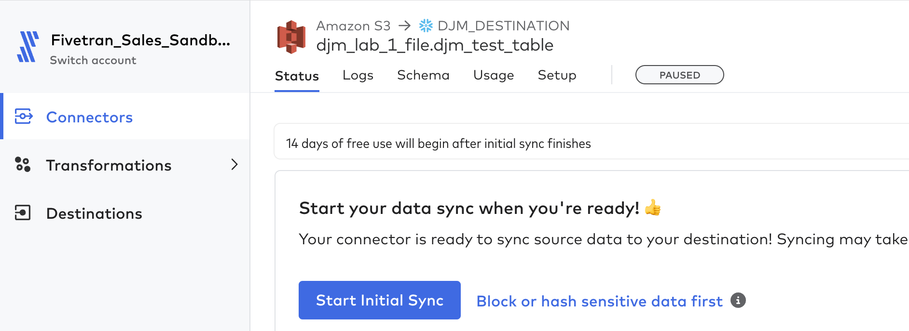

1. Upon starting the initial load, the following screen will appear, instructing the user that the load has started. Note the following, happens while the load is happening:
   1. Syncing symbol - at the top right of the screen the Fivetran logo above ‘Syncing’ fades in and out. When the load is complete the symbol will appear 100% blue.
   2. ‘First time syncing data for this connector’ and a dynamic blue loading circle is displayed at the top center of the screen.
   3. Loading information is placed in the Sync History timeline, this will include the Sync Start, Sync End, Status, Extract Time, Extract Volume, Process Time, Process Volume, Load Time and Load Volume.

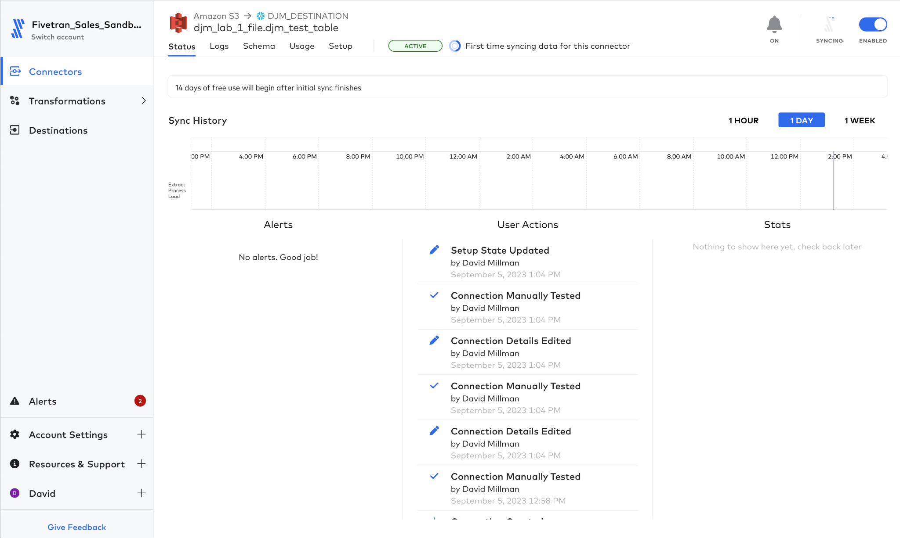

1. Now let’s review the other options available in the connector configuration. Select “**Logs**” this reveals all the actions that have been performed within the connector. It is possible to expand these to see what has happened. Some to expand here are, **create_schema**, **copy_rows** and **records_modified** as shown below. Note that each has a JSON configuration that summarizes what happened at each stage.

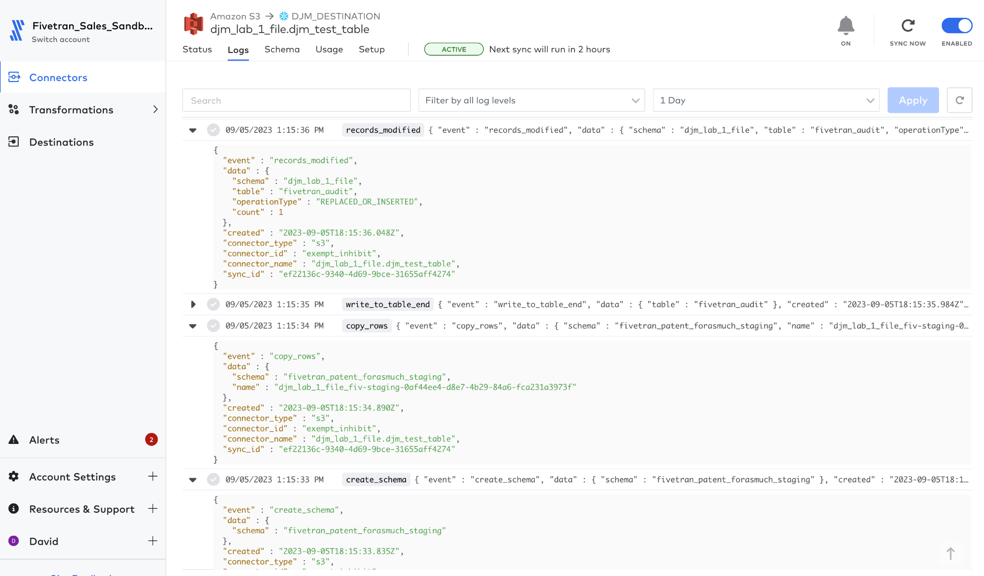

1. Navigate to the ‘Schema’ tab. At no point during the configuration of this connector was the schema specified, or even the type of file such as CSV, TSV, AVRO, parquet, yet Fivetran was able to determine the schema.
2. Also note that any line column with a leading (_) such as **_line**, **_file** and **_modified** is metadata that is automatically added to each line to determine more information about the data (see below).
3. The root of the table should be identical to the ‘Destination Schema’, value configured as part of the connector and the table name is the value from ‘Destination Table’.

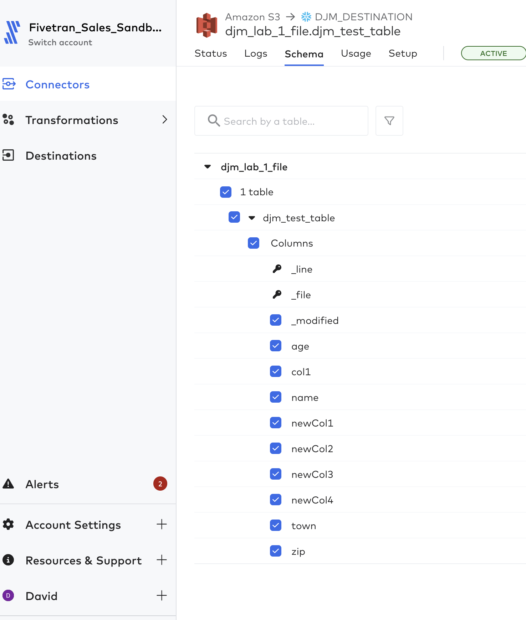

1. Select the ‘Usage’ tab. Note that all connectors are billed via a construct called ‘Monthly Active Rows’ or MAR. As you are using a partner account all the usage is free. Ensure that either none, or all the options are selected in the MAR drop down. ‘**Paid MAR’** is selected by default, by deselecting this the drop down will be as shown in the next screen.
2. For today’s date there should be a single bar that explains how many MAR have been used
3. Below the histogram is a list of tables that have been created. This should include the name of the table shown in the Schema tab, but also an additional table called **fivetran_audit.** Fivetran_audit is a table created and managed by Fivetran and is updated by one or more rows when data is loaded into the target table(s). Every Fivetran connector will create a Fivetran_audit table.

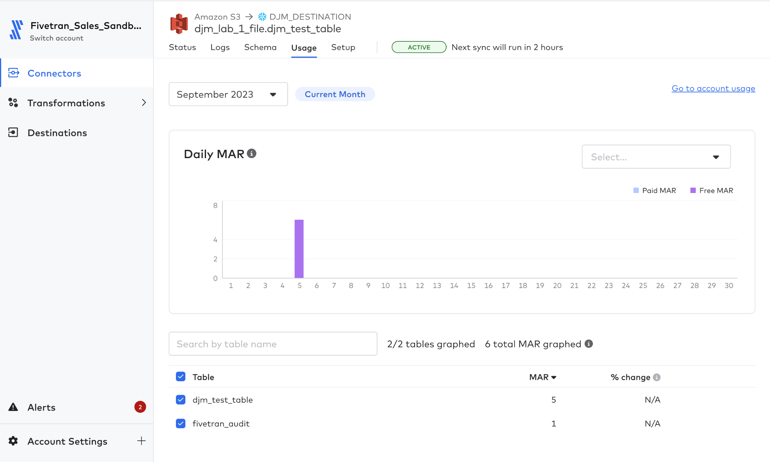

1. The final tab is the Setup screen. At the top of the Setup screen is a summary of how the connector is configured. This shows all the values that were entered in as part of the initial setup.
2. Some parameters were automatically configured as defaults for the connector, these are also listed. Included in the parameters are **File Reading Behavior, Compression Behavior, Error Handling, Modified File Merge, Escape Character, Delimiter, Null Sequence, Headerless CSV?, List Strategy, Connection Method and Require Private Link.**
3. All of these and more can be changed, by selecting ‘Edit Connection details’ at the top right of the screen.

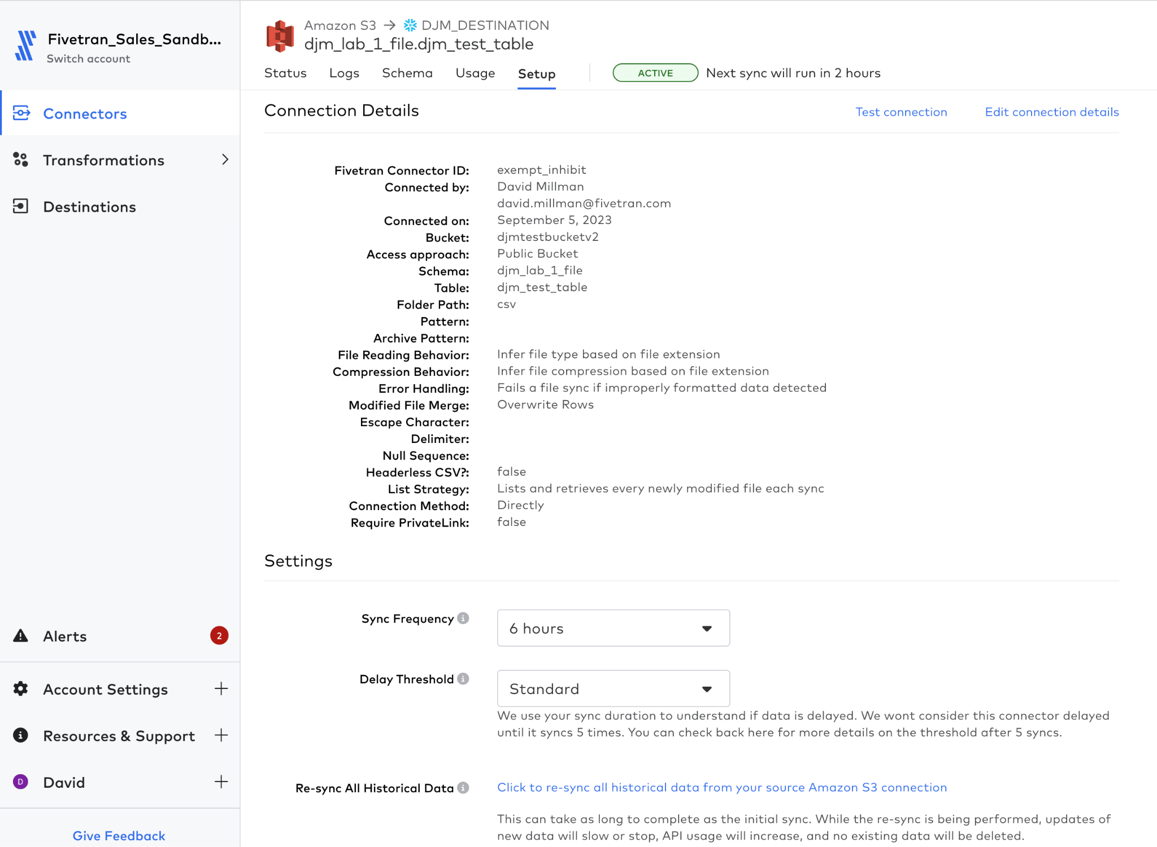

1. Continuing into the Setting section of the delimiter, the following can be set. Just review the following.
   1. Sync Frequency: The interval at which the connector will start up and look for changes. The default is every 6 hours, this can be configured for every minute to every 24 hours.
   2. Delay Threshold: The interval at which the designated party is alerted of a delay in retrieving data. The default action is to try 5 syncs, if it cannot be connected then the connector is considered delayed and a notification is sent out.
   3. Re-sync All Historical Data: This is the equivalent of performing an Initial Sync, all tables are recreated. Note all data in Fivetran_audit will be lost.
   4. Delete Connection: Deletes the connector in Fivetran. **IT WILL NOT DELETE THE DATA IN THE DESTINATION**
2. It is now time to login to the Snowflake destination to review the data that has been loaded.
3. Log back into Snowflake and there are two paths available: one using the data explorer and the other using SQL in a Worksheet (Goto Step 3).
   1. For Data Explorer, in the navbar, expand ‘Data’ and click ‘Database’ item if not already selected. In ‘Search’ navpane, expand the database [CELL-K] and open up the schema that corresponds to that defined in the S3 Connector **[CELL-Q]**, as shown.

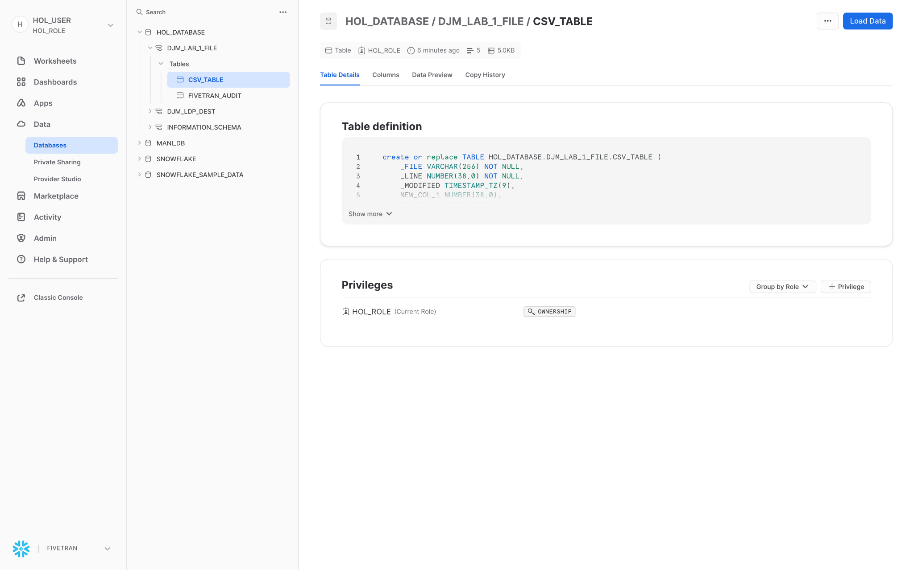

* 1. View the Table Details and expand the TableDefinition, the following is to be noted in the schema
     1. Any column that starts with an underscore (_) is one that fivetran has used to associate metadata with the information, these are:
        1. _FILE - this is the full path to the source file location, including the actual name. This means that each row within the data can be directly linked to a specific file, even if two files of the same name exist within different directories. In this connector all the files found will placed in the same table
        2. _LINE - the line number, starting with 0 that has been used to read the file.
        3. _MODIFIED
        4. _FIVETRAN_SYNCED - the time that the data was synced from the source to the table
     2. The primary key for the table is defined as a combination of the filename and the line number.
     3. All other columns represent the data fields found within the source file(s). The default option with the advanced settings is to use the first row to define the column names, hence Name, Town Zip, New_Col_1 etc.
     4. Types for the column are determined by analyzing the data found within the column, hence NEW_COL_1 being a NUMBER and NEW_COL_2 being a VARCHAR.

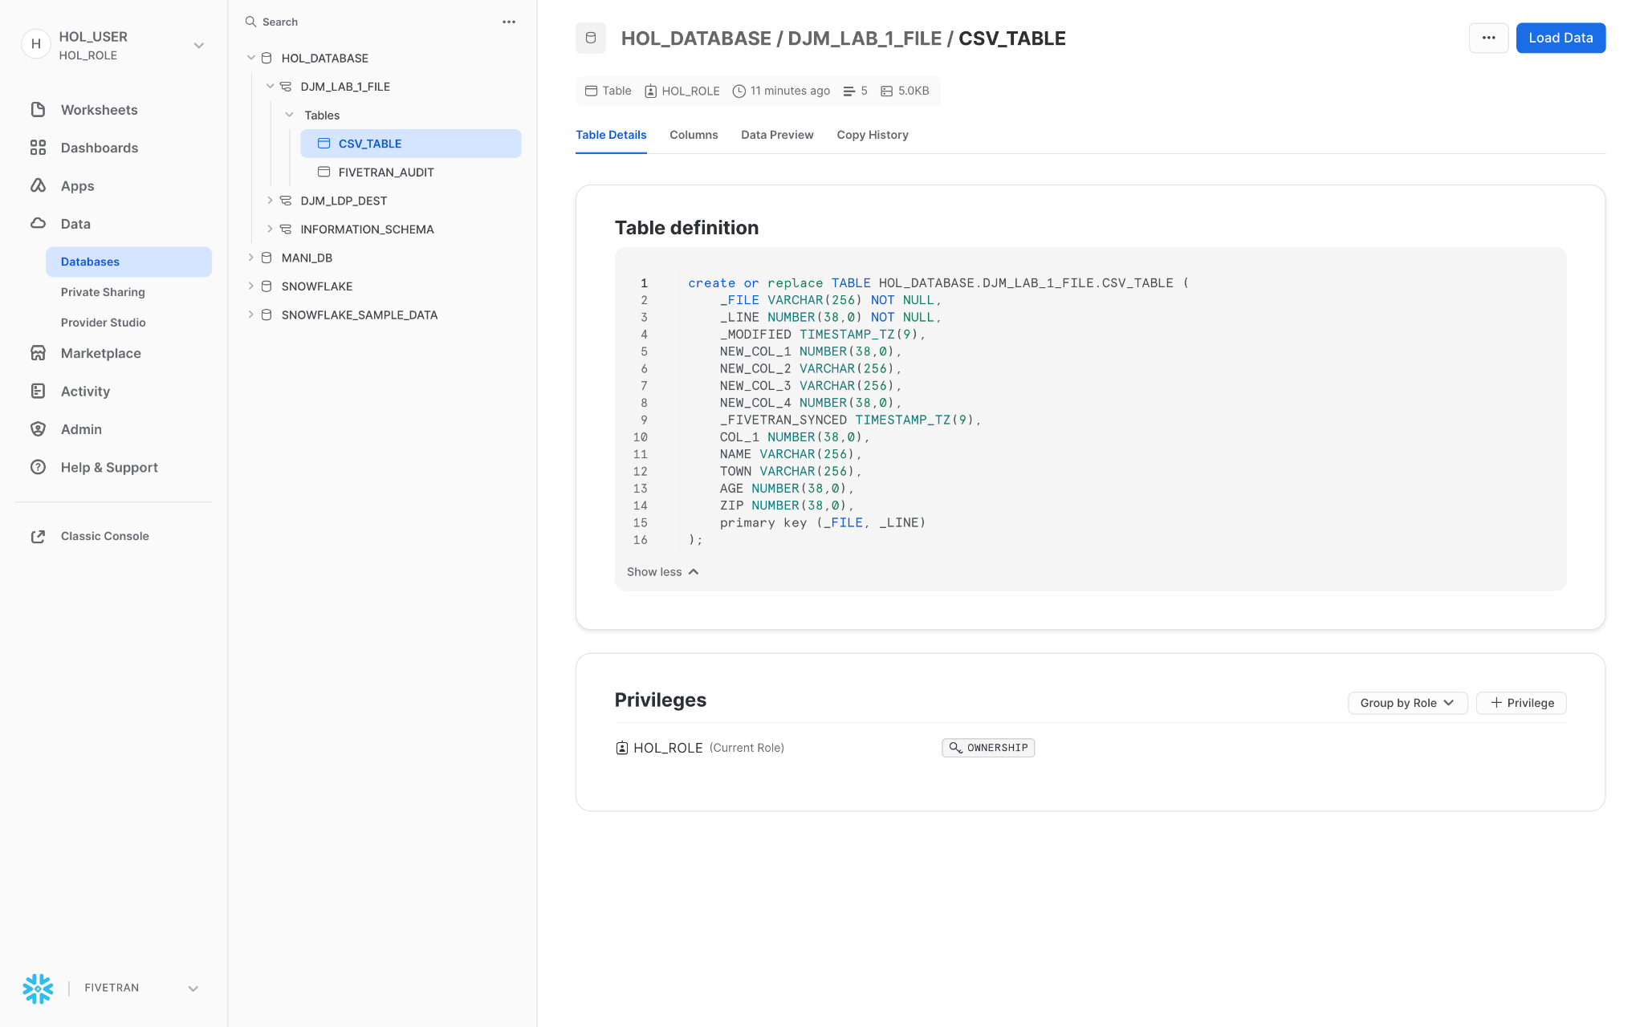

* 1. Click on Data Preview and the information will be shown. There are only 5 records that have been loaded across 3 files (csv/table2.csv, csv/table3.csv, and csv/table4.csv), shown in the _FILE column. Each file has one data row in it, except one (csv/table4.csv) that has 3.

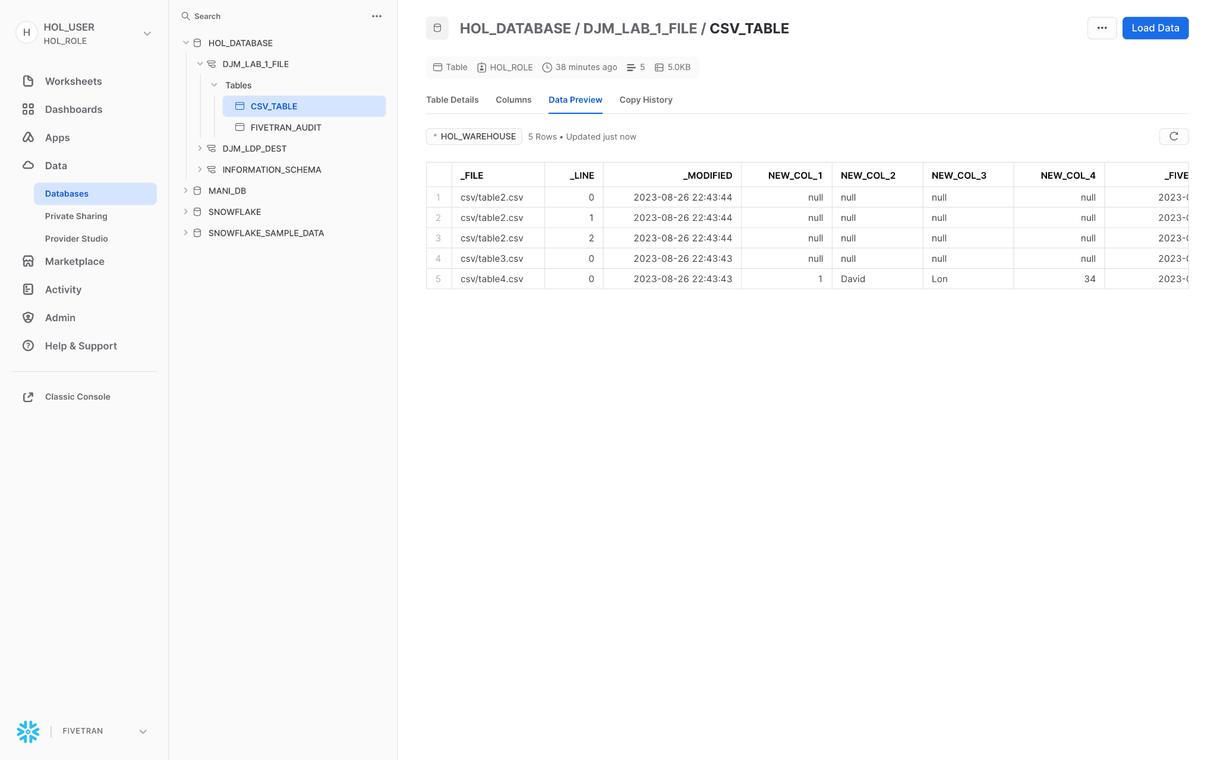

* 1. Where data is not available, i.e. null has been placed in the row.
  2. The actual contents of the bucket are described in APPENDIX - A - Lab 0 Files

1. Alternatively create a workbook to execute SQL statements against the data, using the following
2. To make a Worksheet that can be used, in subsequent labs to run, Select Worksheets, then hit the **[+]** button, to select **‘SQL Worksheet’**

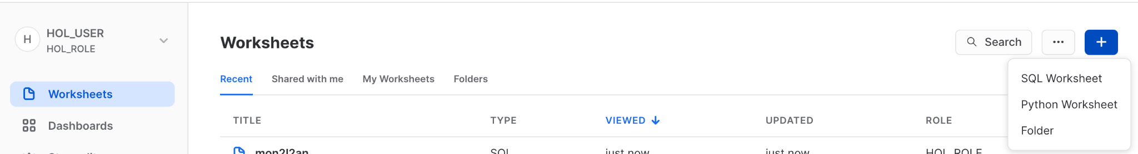

1. Set the name of the worksheet to **[CELL-L]**, the Database to **[CELL-K]** and the Schema to **[CELL-Q]**

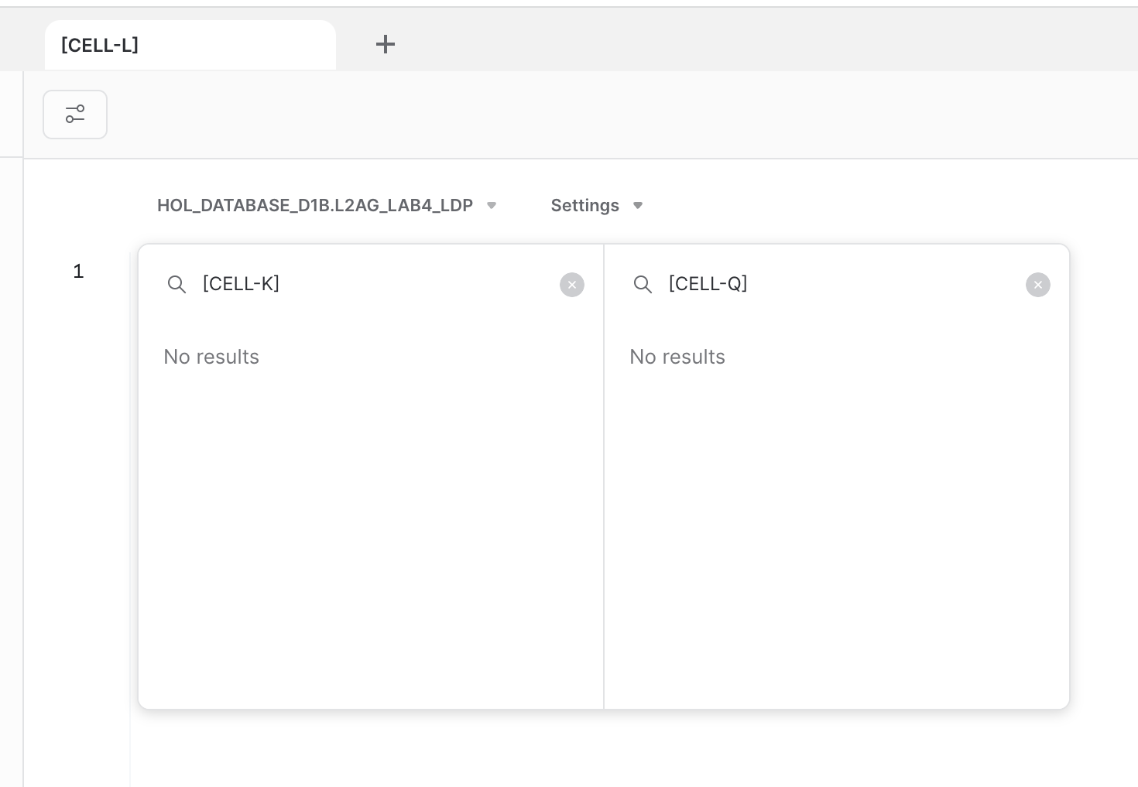

|  |  |
| --- | --- |
| Question |  |
| How many files were loaded into Snowflake | Select count(distinct(_file)) from **[CELL-K].[CELL-Q].csv_table**; |
| List all the files that were loaded | Select distinct(_file) from **[CELL-K].[CELL-Q].csv_table**; |

1. Let’s review the structure of the table.
2. What are the types of the columns?
3. Let’s review all the columns.
4. Any reason why _modified appears in the middle of the table?
   1. Clue, navigate back to the Status tab for this connector and refresh, or look for any **‘Change_schema_config_via_sync’** events in the log tab.

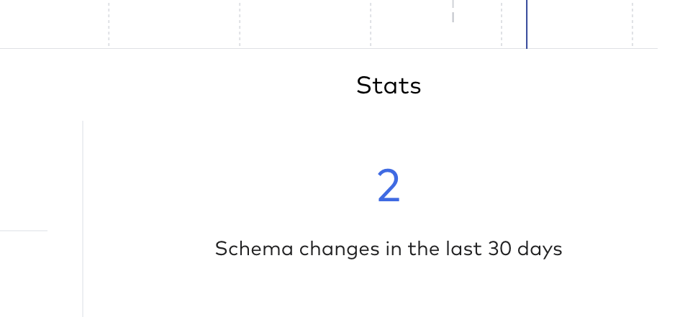

1. Why are some null?
2. To compare the contents of the table created and the table review APPENDIX - A - Lab 0 Files

# Certification Login Test

At the end of each Lab you will sit a certification test to ensure that you’ve understood the key concepts and more importantly can receive a badge as well as Fivetran branded SWAG.

In this first section, we need to ensure that you can access the tests.

Please follow the link [HERE](https://fivetran.zinfi.net/concierge/ucm/#/ucm/1298/1108/v/19) to view a test (DO NOT TAKE IT YET).

If you cannot access the test, please let the instructor(s) know.

# Lab 2 - Databases - Teleport - Analytic DB as a Source

At a high level databases normally have a standard architecture, but some deployments such as RDS (Relational Database Service) allow access to the SQL layer, NOT to the underlying Transaction Log. This is also true for Analytic databases such as Teradata, Snowflake, and Redshift as sources.

Standard Database Connectors automate the movement of data from the source to the target without needing access to the redo/transaction log via the database API. In this lap, we will use the database API for an analytic source (Snowflake) and for a RDS source (Postgres)

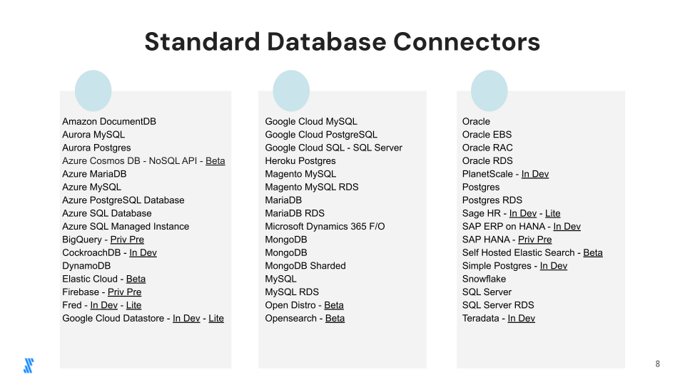

## 2.1 - Snowflake as a Source and Target

In this lab, a copy of the file data loaded in Lab 1 will be replicated to another Snowflake schema in the same account. Note that this is just an example of utilizing Snowflake as a source versus creating a new destination.

1. Navigate to the connectors page of Fivetran

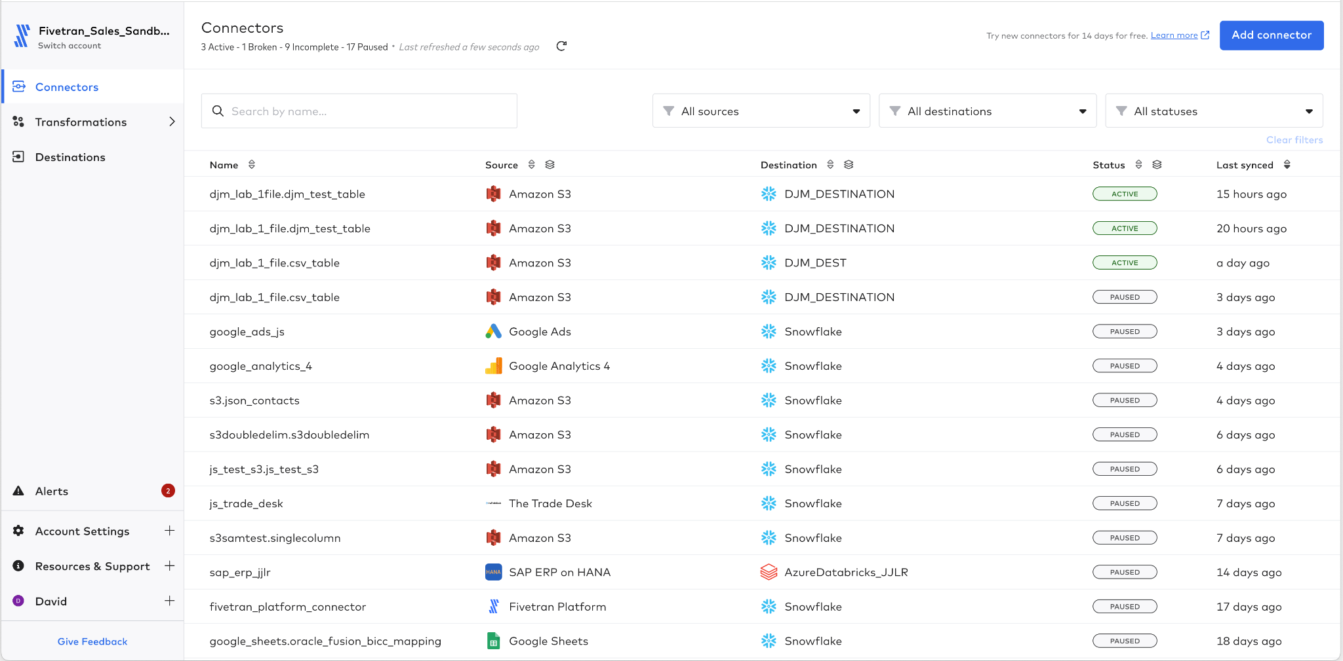

1. Select Add Connector 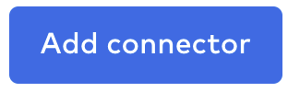
2. Select the destination that was created in the earlier lab **[CELL-M]**

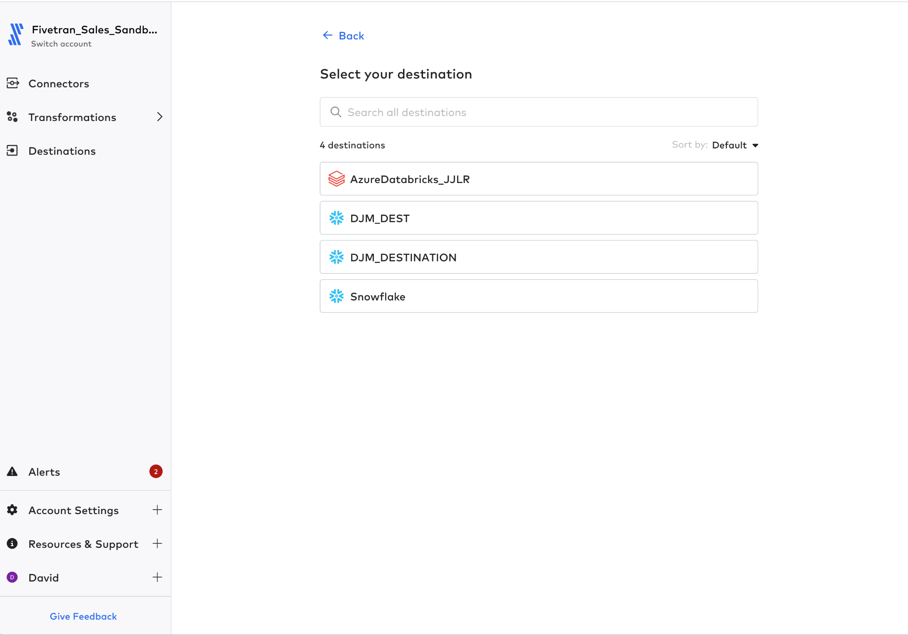

1. Select ‘Snowflake’ as a source. Note that this connector is in Beta meaning it is not fully supported but can be used in demos and testing.

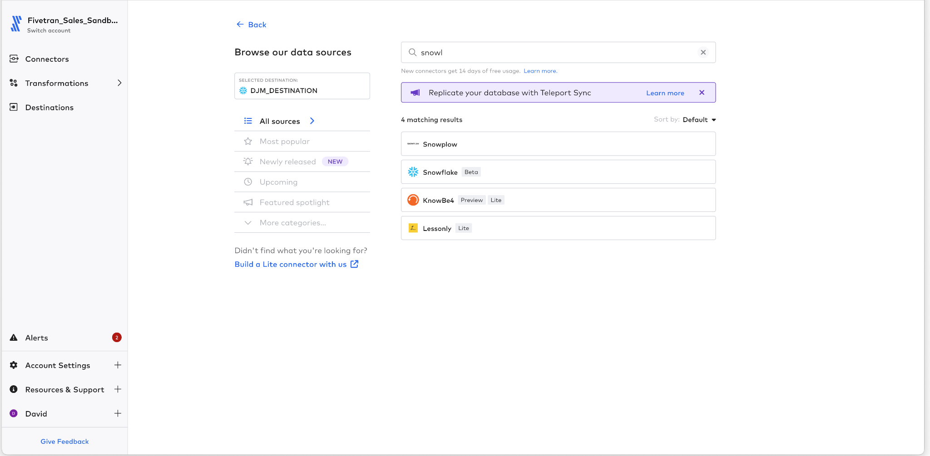

1. Fill in the parameters for the connector:

|  |  |
| --- | --- |
| Destination Schema | **CELL-U** |
| Host | **fivetran.snowflakecomputing.com** |
| Port | 443 |
| User | **hol_user** |
| Database | **HOL_REFERENCE** |
| Auth | **Password** |
| Password | **gojMjrpwWFzjYeKbVmRw** |

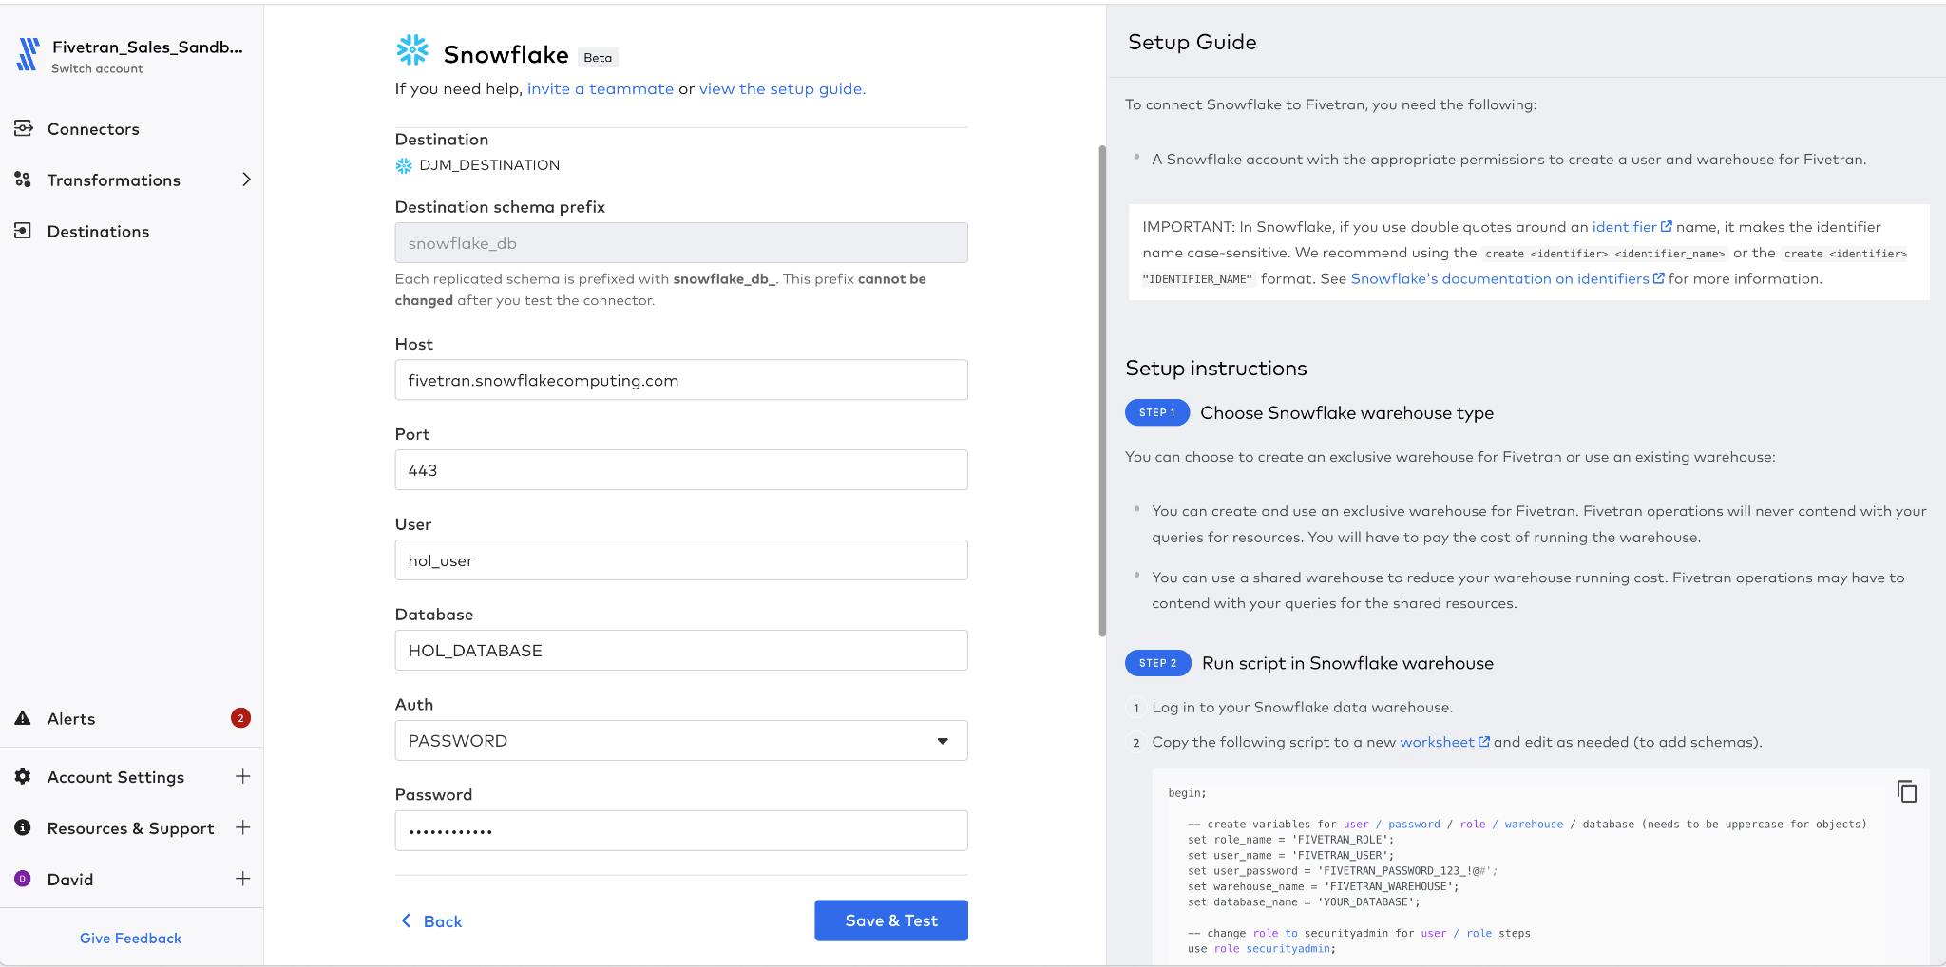

1. Select Save & Test
2. Run the connection tests to ensure that Fivetran can connect to Snowflake as a source.

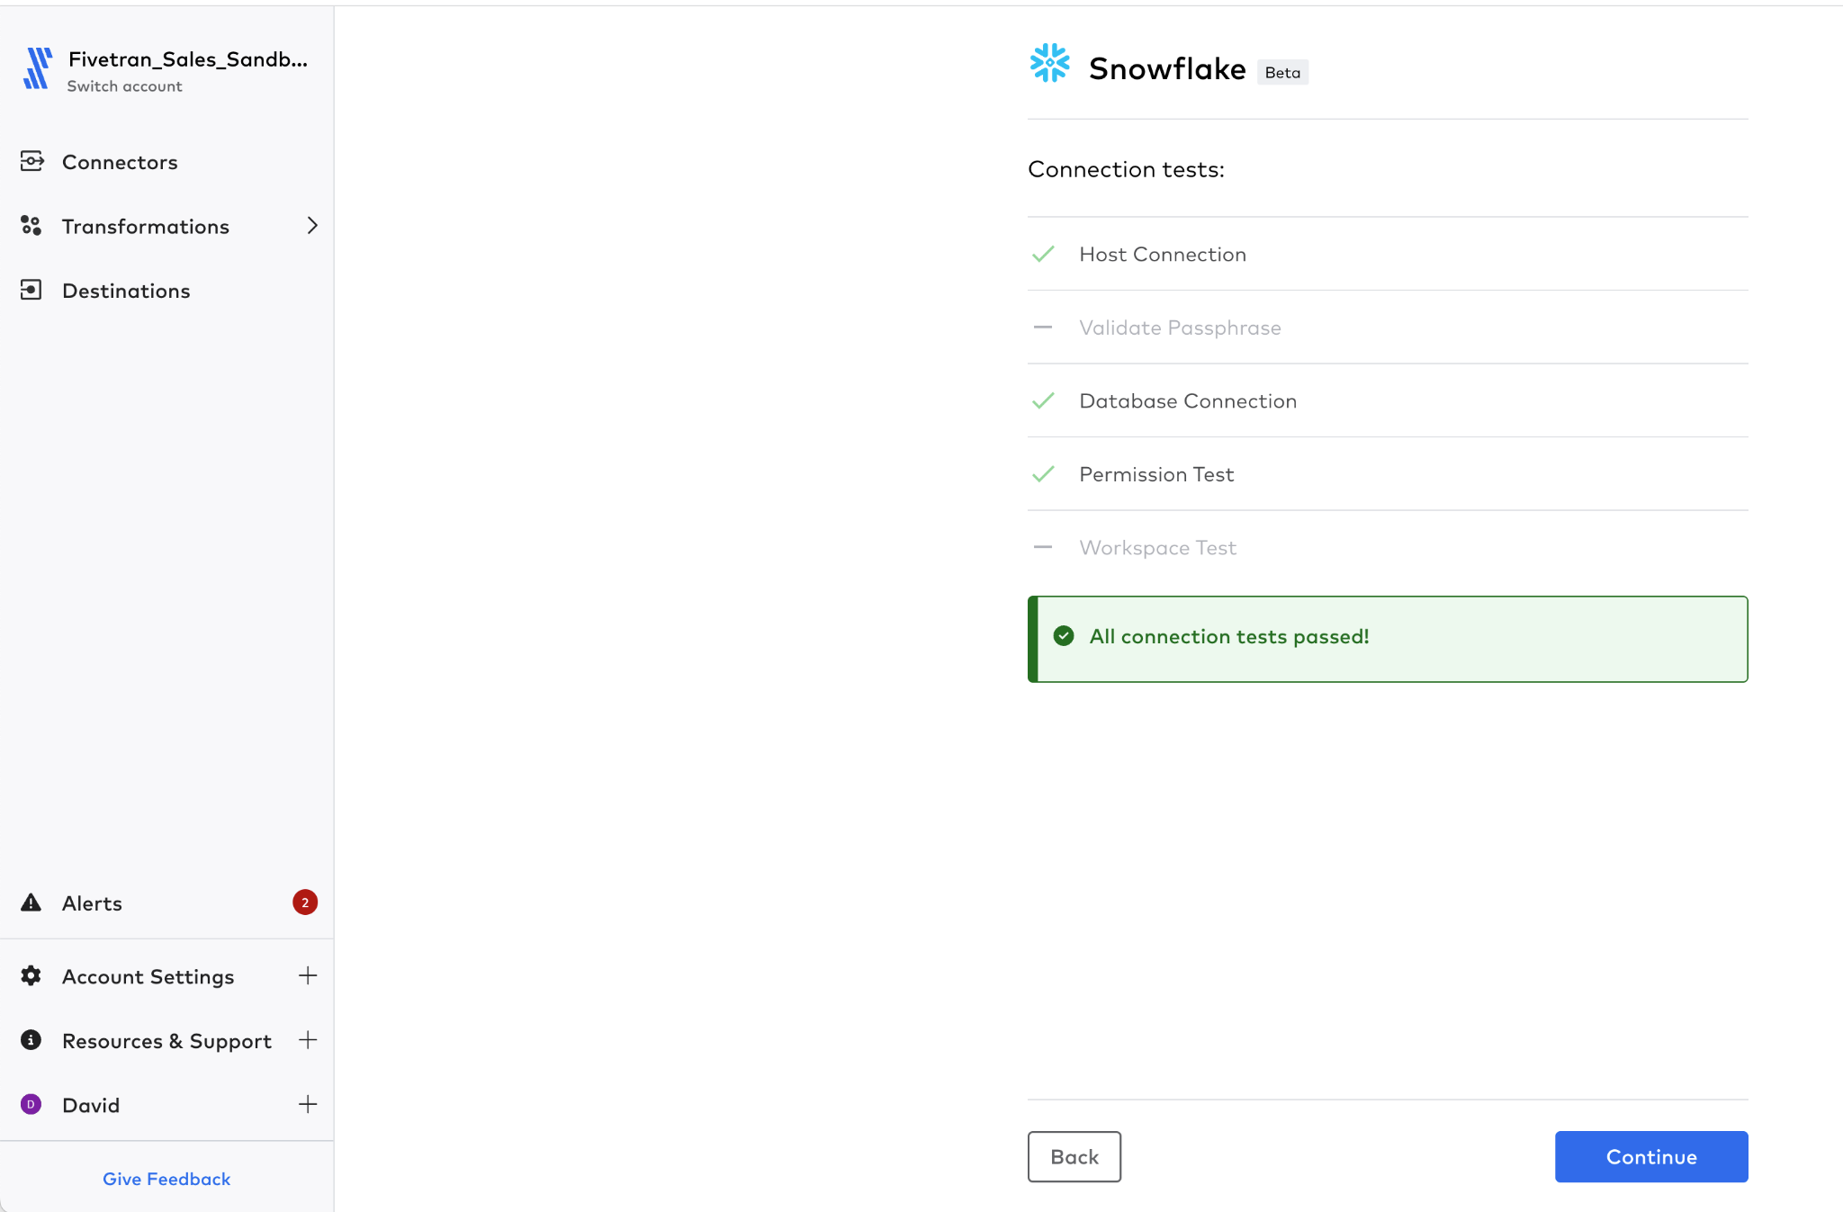

1. The schemas are now read and listed for you. Find the schema this is called **FILE_DATA**
   1. What happens if you try to Select the table FIVETRAN_AUDIT
      1. It is a reserved word so cannot be propagated across.
   2. Expand the data table CSV_TABLE
      1. Note that _FIVETRAN_SYNCED is also not selectable for the same reason, yet other metadata fields such as _LINE and _FILE are automatically selected.
      2. Does this make sense?

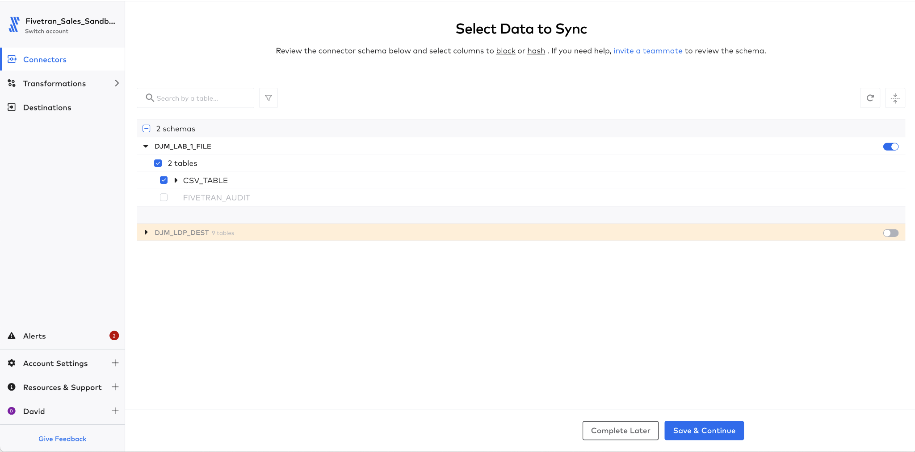

1. Once the schema is selected, press ‘**Save & Continue**’
2. Ensure that Fivetran will automatically manage all the changes, by selecting **Allow All**

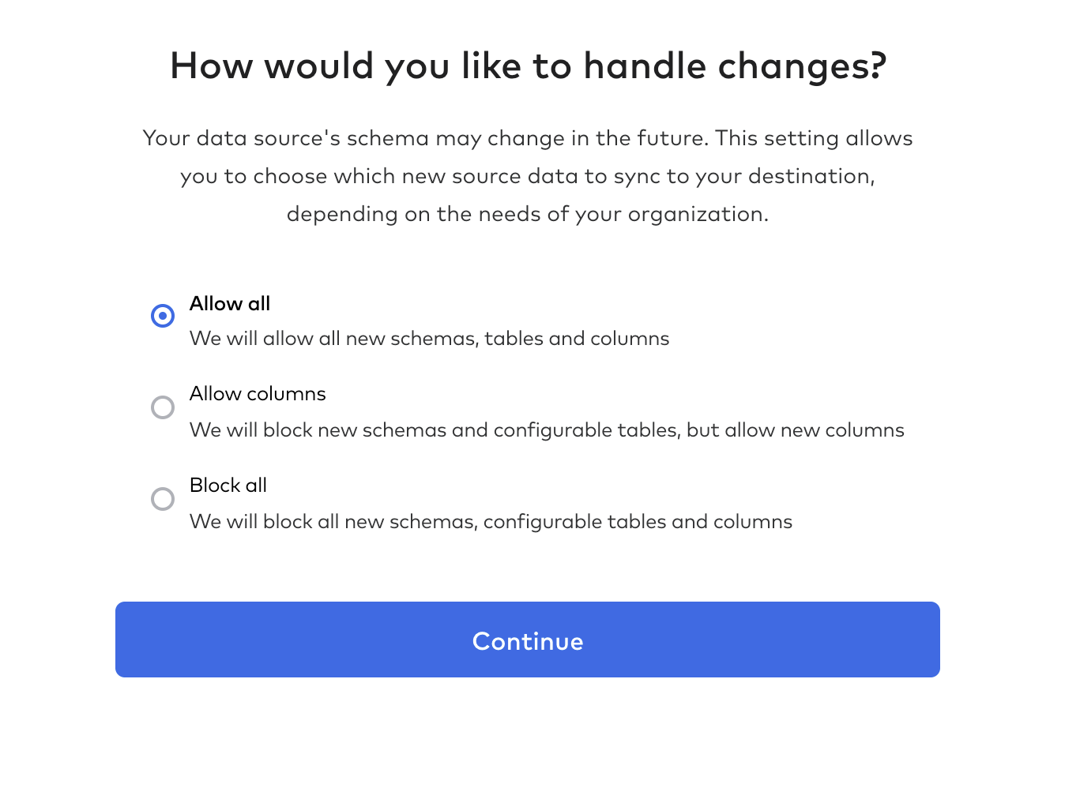

1. Start the initial sync by selecting the ‘Start Initial Sync’ button.

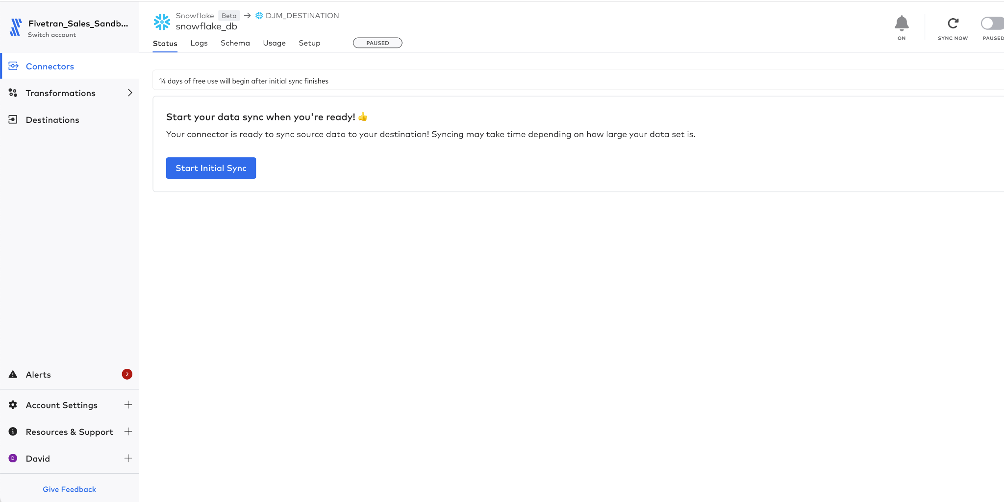

1. Review the data in Snowflake.

## 2.2 Teleport and Transactional Databases as a Source

In this lab, options are shown for multiple types of CDC based on what database you choose. There is the DBMS’s logical replication modes and one more added by Fivetran - Teleport. Teleport is a replication process by which all tables are scanned for any changes compared to the previous run. We will be using Teleport CDC today.

1. In Fivetran.com navigate to the connectors page



1. Select Add Connector 
2. Select the Destination that was created earlier **[CELL-M]**



1. In the search window, type **Postgres.** This will display all the Postgres options, note there are a number of options:
   1. Postgres - this is the standard Postgres connector, if installed on-premise or on a virtual machine in a cloud then this should be used. Note, if you try to use this instance on a RDS or similar instance, it normally warns you that there is a better connector.
   2. Postgres RDS - fully managed/hosted by AWS RDS
   3. Google Cloud PostgreSQL - fully managed/hosted Google Cloud
   4. Aurora Postgres
   5. Heroku Postgres
   6. Azure PostgreSQL Database - fully managed/hosted by Azure
2. The instance accessed in this lab is hosted in Google Cloud, so select **‘Google Cloud PostgreSQL Database.**

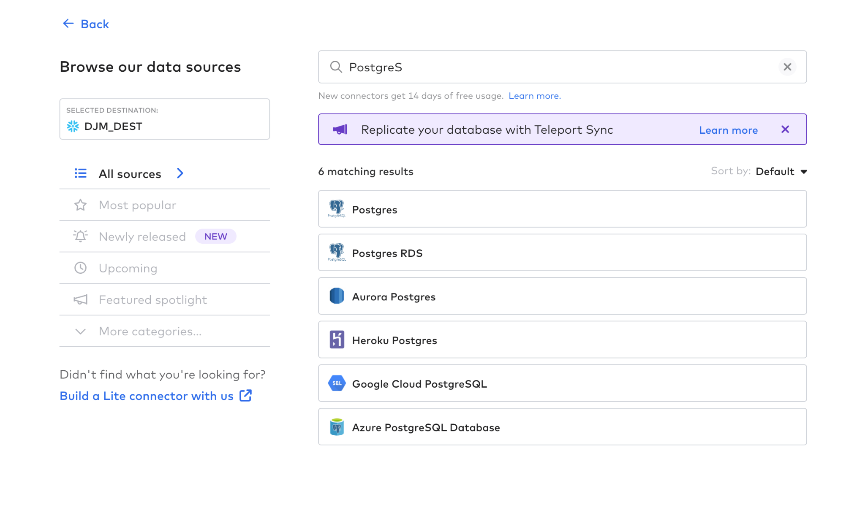

1. Enter the connection information for the lab:

|  |  |
| --- | --- |
| Host | **[CELL-W]** |
| Port | 5432 |
| User | fivetran |
| Password | **gojMjrpwWFzjYeKbVmRw** |
| Database | retail |
| Connection Method | Connect Directly |
| Update Method | **Detect Changes via Fivetran Teleport Sync** |

1. Click the ‘Save & Test’ button.

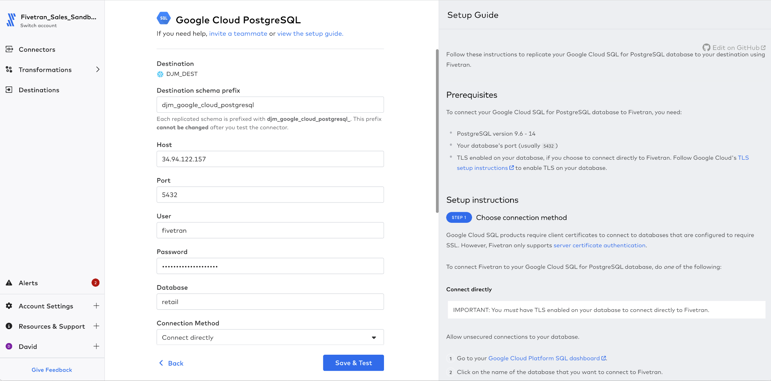

1. Since we are connecting directly over the public internet a certificate is required. You will be prompted to select the certificate. Then click the ‘Confirm’ button. The validation steps will restart.

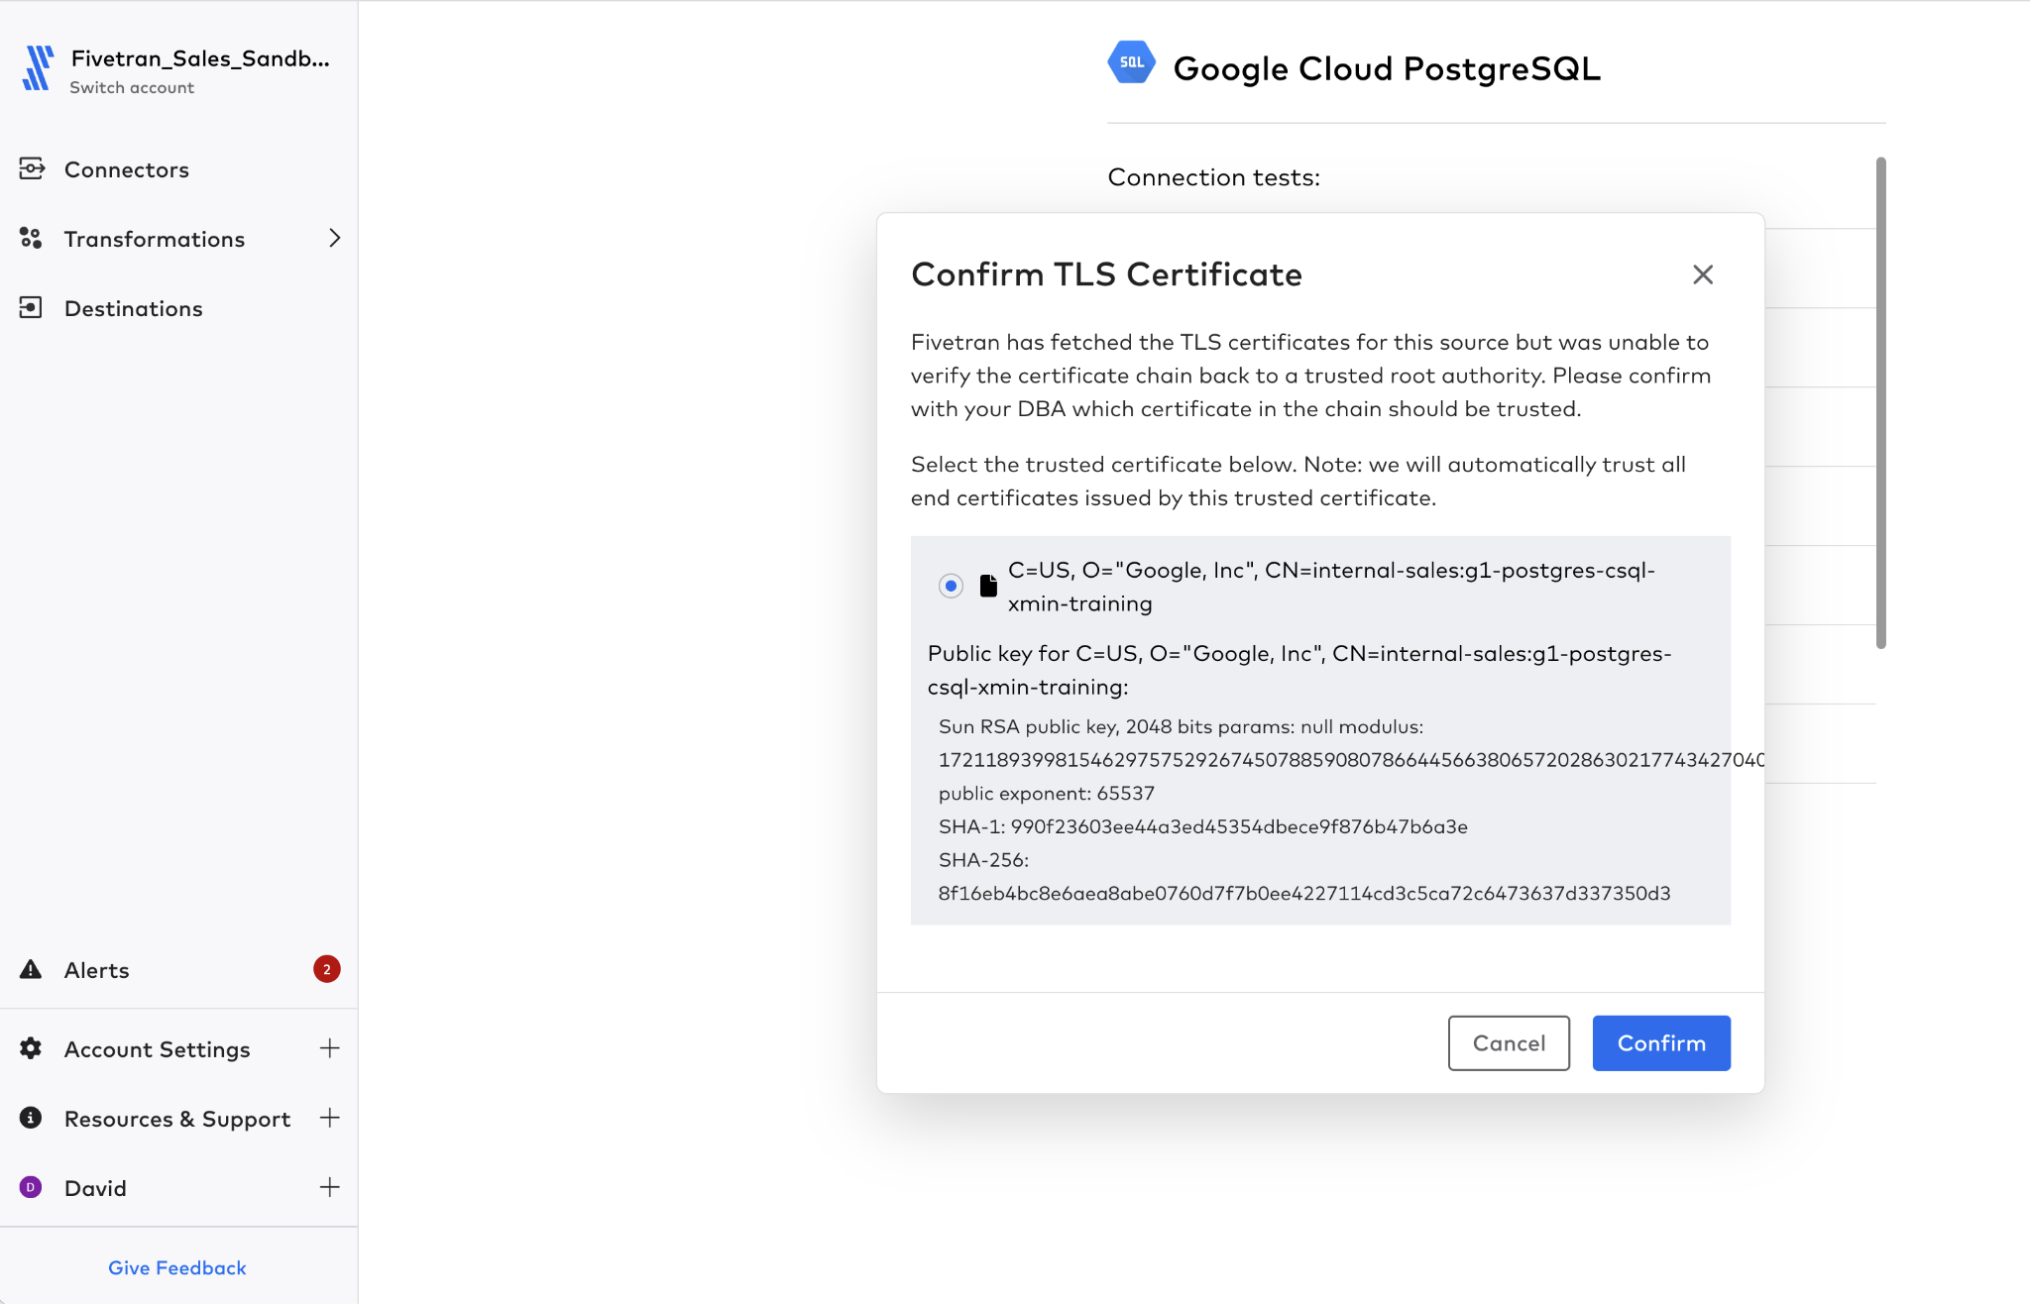

1. The tests now run and execute, on success a green ‘All Connection tests passed’ will be displayed
   1. Note, not all the tests are actually executed
      1. **Connecting to SSH tunnel -** is not executed as the network connection is a direct link, therefore not using a tunnel of any nature.
      2. **Connecting to host -** this is execute to validate that the Fivetran pipeline can connect to the actual host
      3. **Validating certificate**  - when a TLS connection is implemented, this validates the certificate is valid
      4. **Connecting to the Database** - tests that the defined username/password combination can connect to the database **retail**
      5. **Connecting to WAL replication slot**  - as this is not required for the Teleport connection it is not used
      6. **Checking configuration values -** no configuration changes have been performed on the database, so no configuration to check
      7. **Verifying Publication -** no change events are being published so not test required
      8. **Creating BIT_XOR aggregate -**
      9. **Checking XMIN extensions -** XMIN is not being used to test for changes, so not checked
      10. **Checking ‘statement_timeout’** **value** - as Teleport is going to issue a number of SQL queries this validates that a reasonable timeout value is set, especially for larger tables.
   2. Press **Continue**

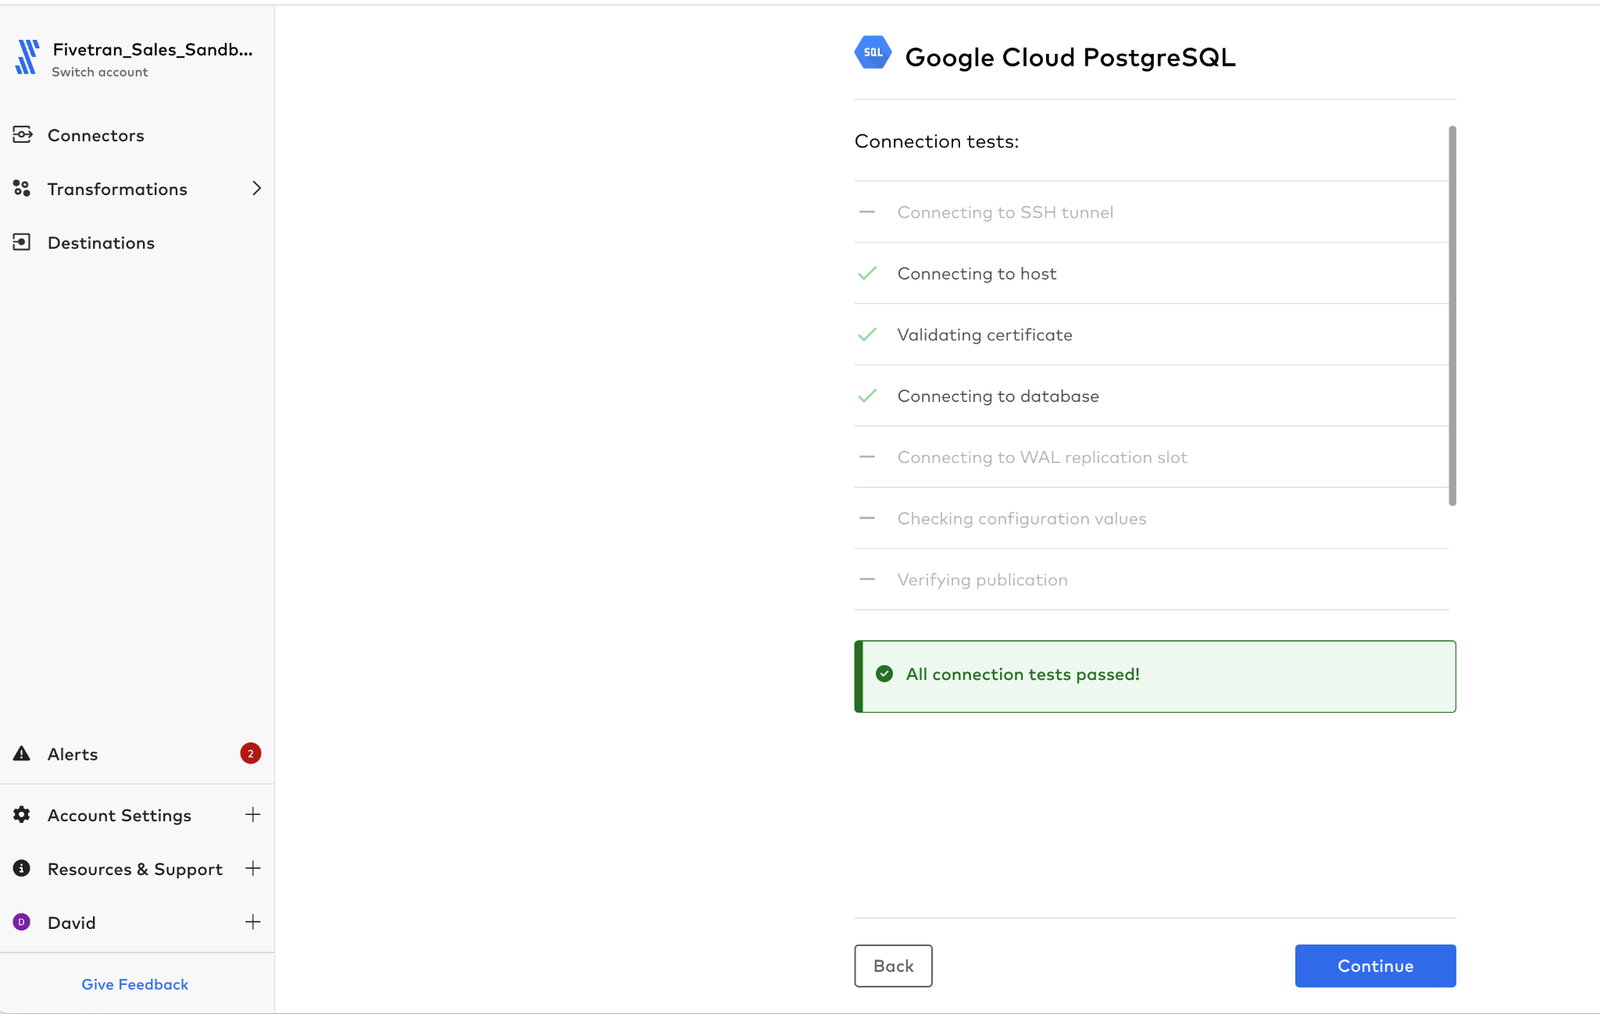

1. Fivetran will then query the schema information on that database and present the findings. Ensure that only one schema is selected (for lab purposes only).
   1. customers
   2. loyalty_segments
   3. sales_orders

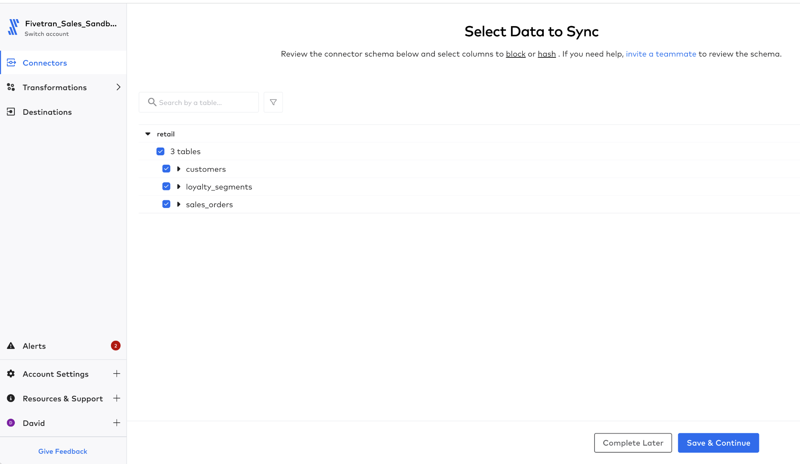

1. Expand the ‘customers’ table as shown

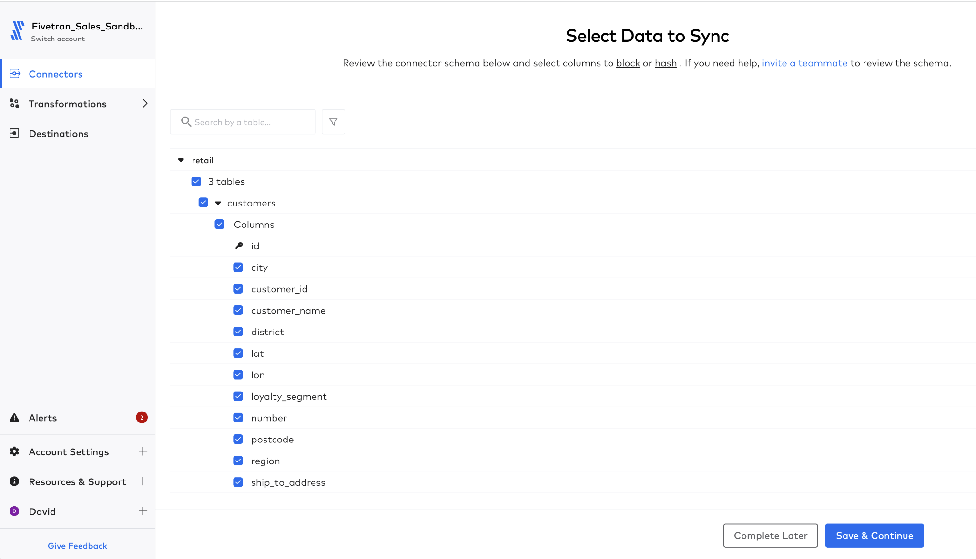

1. Highlight the ‘number’ field and select the ‘Hashed’ option. This means that all the records will be copied using a one way hash to the target.

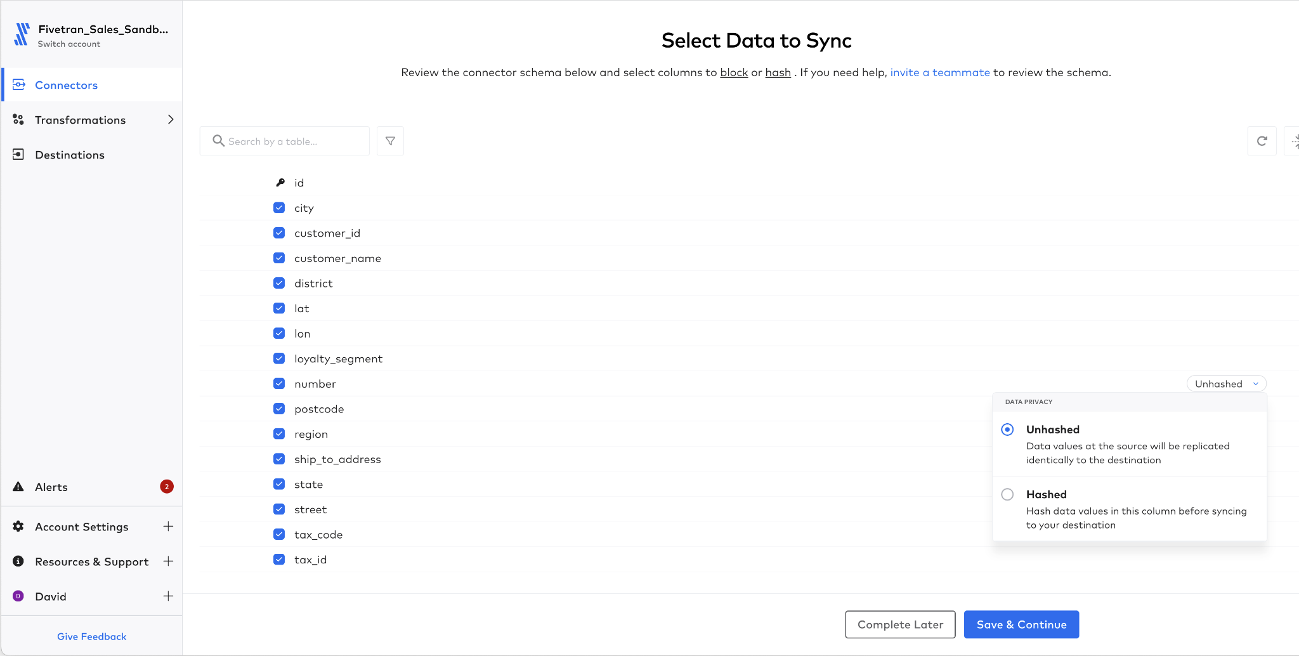

1. Click the ‘Save and Continue’ button.
2. For the handling of schema changes dialog, select ‘Allow All’ and click ‘Continue’.



1. Next click the ‘Start Initial Load’ button.

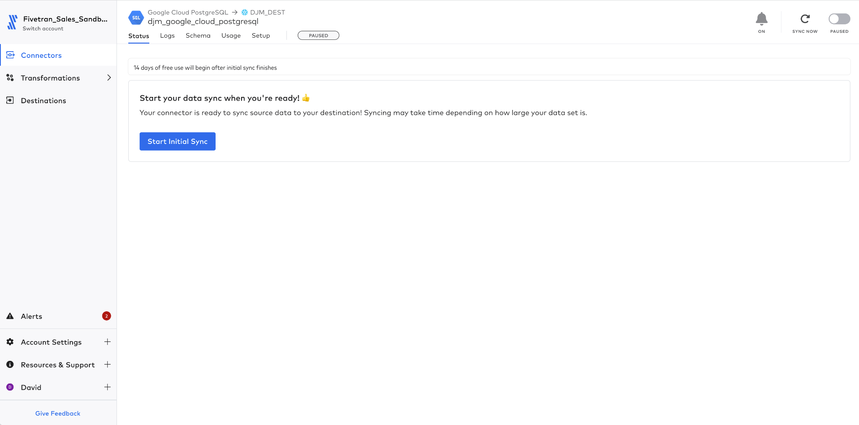

1. Review the data in Snowflake when the load is complete.

**CONGRATULATIONS You’ve completed all the labs, for the first certification test** [**HERE**](https://fivetran.zinfi.net/concierge/ucm/#/ucm/1298/1108/v/20)

**Please have your 100 Fivetran Facts available**

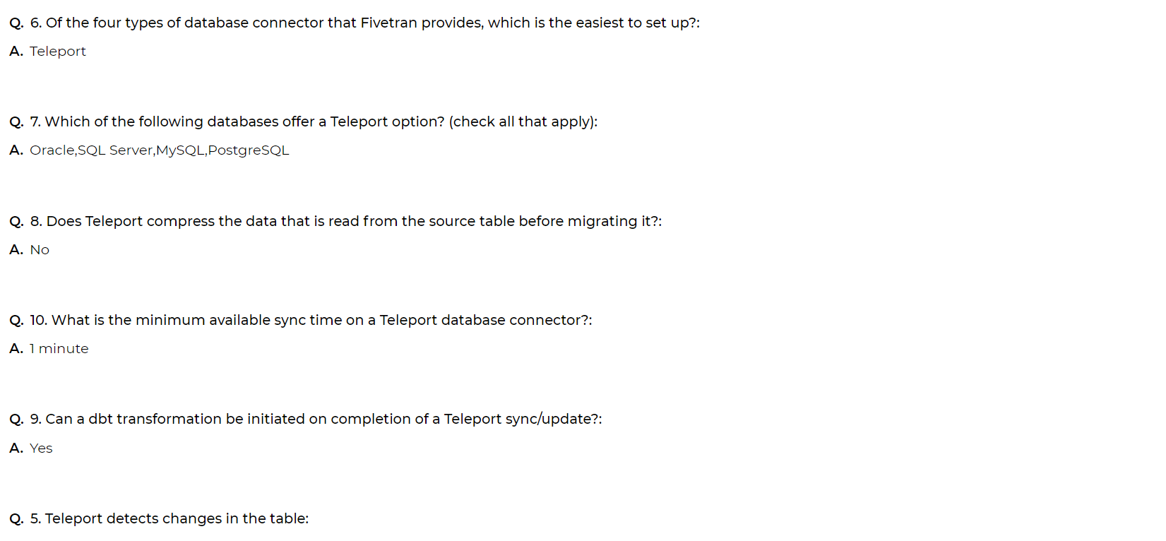

# 

# Lab 3 - Logical Replication and HVA Deployments

This lab consists of two parts, these being:

* 3.1 - Using Native Database Change Detection - use Postgres’ ability to detect changes using the XMIN column and also see what happens if the database is not optimally configured
* 3.2 - HVA Configuration - how to configure the agent based connector to read the database’s transaction log.

## 3.1 - Using Native Database Change Detection

In this lab the Postgres instance that was used for Teleport as a source, will have a new version that uses the Native Postgre way of detecting changes, called xmin.

xmin

The identity (transaction ID) of the inserting transaction for this row version. (A row version is an individual state of a row; each update of a row creates a new row version for the same logical row.)

This means that Fivetran can detect and determine changes just using a column value that already exists in the data.

1. In Fivetran.com navigate to the connectors page



1. Select Add Connector 
2. Select the Destination that was created earlier **[CELL-M]**



1. In the search window, type **Postgres.** This will display all the Postgres options, note there are a number of options:
   1. Postgres - this is the standard Postgres connector, if installed on-premise or on a virtual machine in a cloud then this should be used. Note, if you try to use this instance on a RDS or similar instance, it normally warns you that there is a better connector.
   2. Postgres RDS - fully managed/hosted by AWS RDS
   3. Google Cloud PostgreSQL - fully managed/hosted Google Cloud
   4. Aurora Postgres
   5. Heroku Postgres
   6. Azure PostgreSQL Database - fully managed/hosted by Azure
2. The instance accessed in this lab is hosted in Google Cloud, so select **‘Google Cloud PostgreSQL Database.**



1. Enter the connection information for the lab:

|  |  |
| --- | --- |
| Destination Schema | **[CELL-V]_ xmin** |
| Host | **[CELL-W]** |
| Port | **5432** |
| User | **fivetran** |
| Password | **gojMjrpwWFzjYeKbVmRw** |
| Database | **retail** |
| Connection Method | **Connect Directly** |
| Update Method | **Detect Changes via XMIN** |

1. Click the ‘Save & Test’ button.

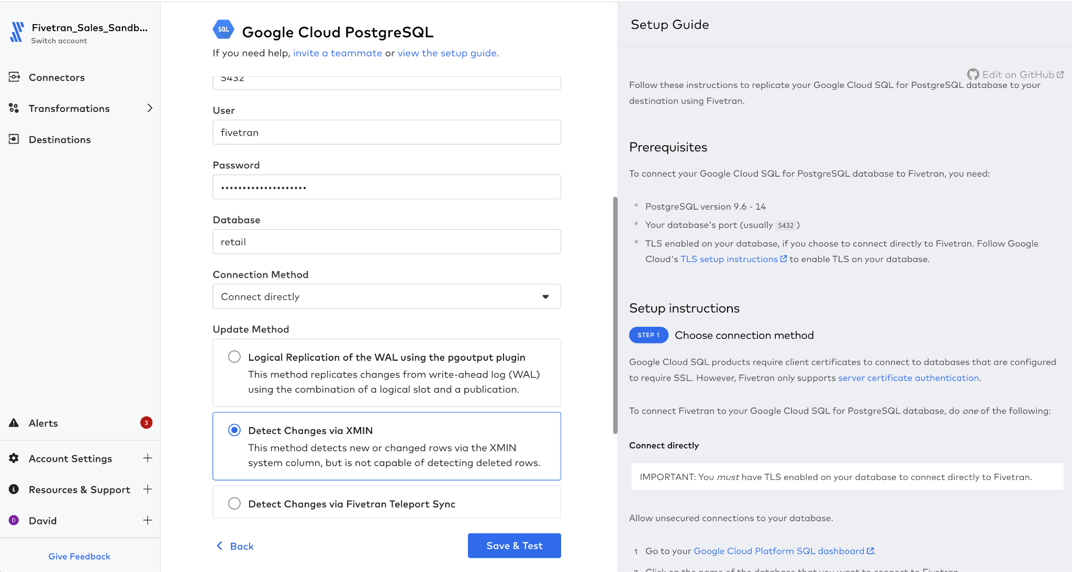

1. Since we are connecting directly over the public internet a certificate is required. You will be prompted to select the certificate. Then click the ‘Confirm’ button. The validation steps will restart.



1. The tests now run and execute, on success a green ‘All Connection tests passed’ will be displayed
   1. Note, not all the tests are actually executed
      1. **Connecting to SSH tunnel -** is not executed as the network connection is a direct link, therefore not using a tunnel of any nature.
      2. **Connecting to host -** this is execute to validate that the Fivetran pipeline can connect to the actual host
      3. **Validating certificate**  - when a TLS connection is implemented, this validates the certificate is valid
      4. **Connecting to the Database** - tests that the defined username/password combination can connect to the database **retail**
      5. **Connecting to WAL replication slot**  - as this is not required for the Teleport connection it is not used
      6. **Checking configuration values -** no configuration changes have been performed on the database, so no configuration to check
      7. **Verifying Publication -** no change events are being published so not test required
      8. **Creating BIT_XOR aggregate -**
      9. **Checking XMIN extensions -** Checks that a number of parameters are set beyond just XMIN. If they are NOT set XMIN will still work, however, there might be some extra costs at certain times.
      10. **Checking ‘statement_timeout’** **value** - as Teleport is going to issue a number of SQL queries this validates that a reasonable timeout value is set, especially for larger tables.

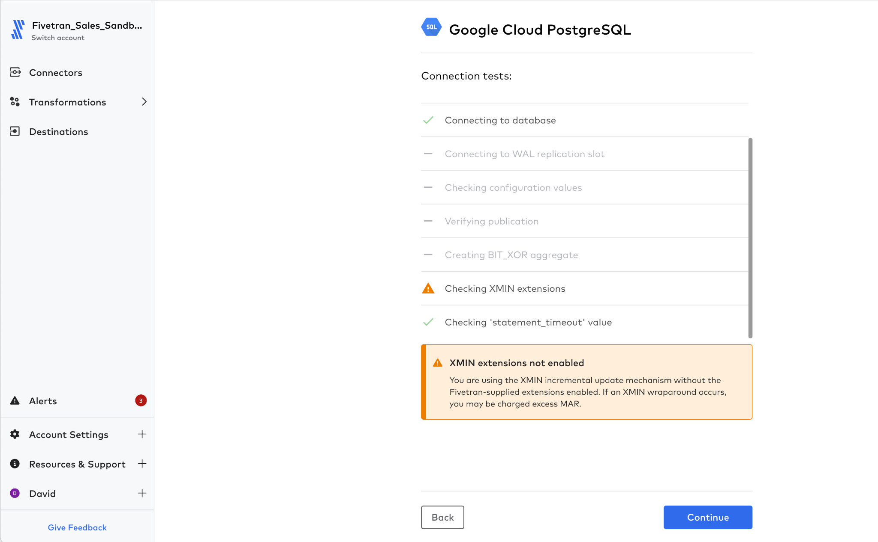

* 1. In this case the tests show that while XMIN is available, however there are chances that additional MAR may happen as the XMIN value rolls over. THe database workaround is [here](https://fivetran.com/docs/databases/postgresql#solution)
  2. As this is just a test, **Press Continue**

1. Fivetran will then query the schema information on that database and present the findings. Ensure that only one schema is selected (for lab purposes only).
   1. customers
   2. loyalty_segments
   3. sales_orders



1. Expand the ‘customers’ table as shown



1. Highlight the ‘number’ field and select the ‘Hashed’ option. This means that all the records will be copied using a one way hash to the target.



1. Click the ‘Save and Continue’ button.
2. For the handling of schema changes dialog, select ‘Allow All’ and click ‘Continue’.



1. Next click the ‘Start Initial Load’ button.



1. Review the data in Snowflake when the load is complete.

## 3.2 - HVA Configuration

HVA deployments require an installation of an Agent on the same machine as the database to read the binary log.

1. Navigate to the connectors page



1. Press ‘Add Connector’ 
2. Select the destination **[CELL-M]**



1. In the connector search bar enter ‘**High Volume**’
   1. The High Volume Agent architecture supported databases are listed.
      1. DB2 for iSeries
      2. Oracle
      3. SQL Server
   2. Also note that this same type of connector can be used for SAP ECC (ERP Central Component) the previous version of SAP before SAP/S4. ECC installations are supported on the following databases.
      1. Oracle (With Enterprise or Runtime License)
         1. Runtime license is supported using Oracle with Netweaver
      2. DB2 i-Series
      3. SQL Server

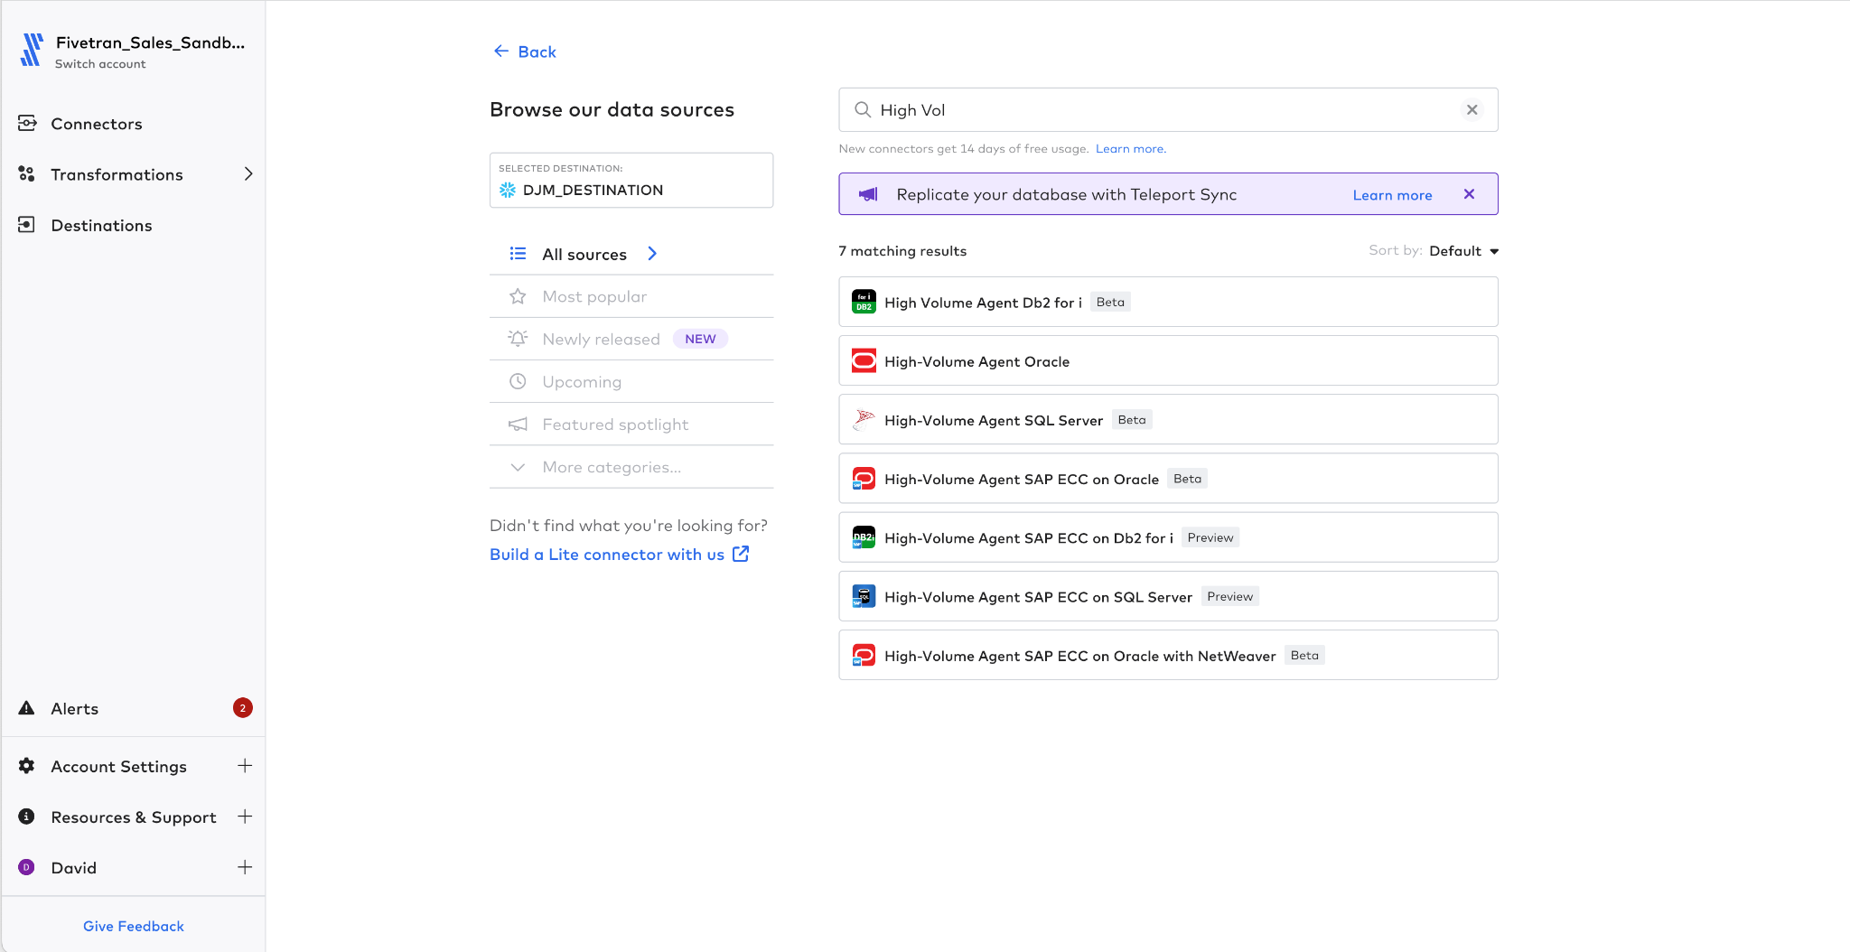

1. Select **‘High-Volume Agent for SQL Server’** note this might still be Beta so is not fully supported in production at this time, but is available for internal testing. Use the values in the following table to set the HVA connector

|  |  |
| --- | --- |
| Destination Schema Prefix | **[CELL-AB]** |
| Host | **localhost** |
| Port | 1433 |
| User | fivetran |
| Password | **pXxULy4T6qVvoCfDM6AJ** |
| Database | **sqlserver** |
| Connection Method | **Connect Directly** |
| Agent Host | **[Cell-AE]** |
| Agent Port | **4343** |
| Agent Use Id | **hvr** |
| Agent User Password | **PiB8ukqWwnHD88RJnewV** |
| Agent Public Cert |  |

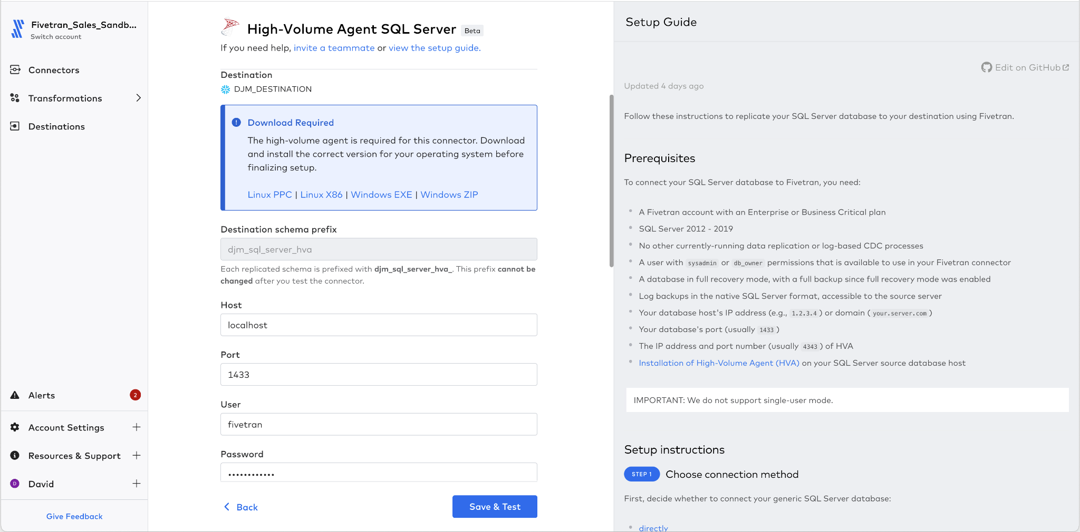

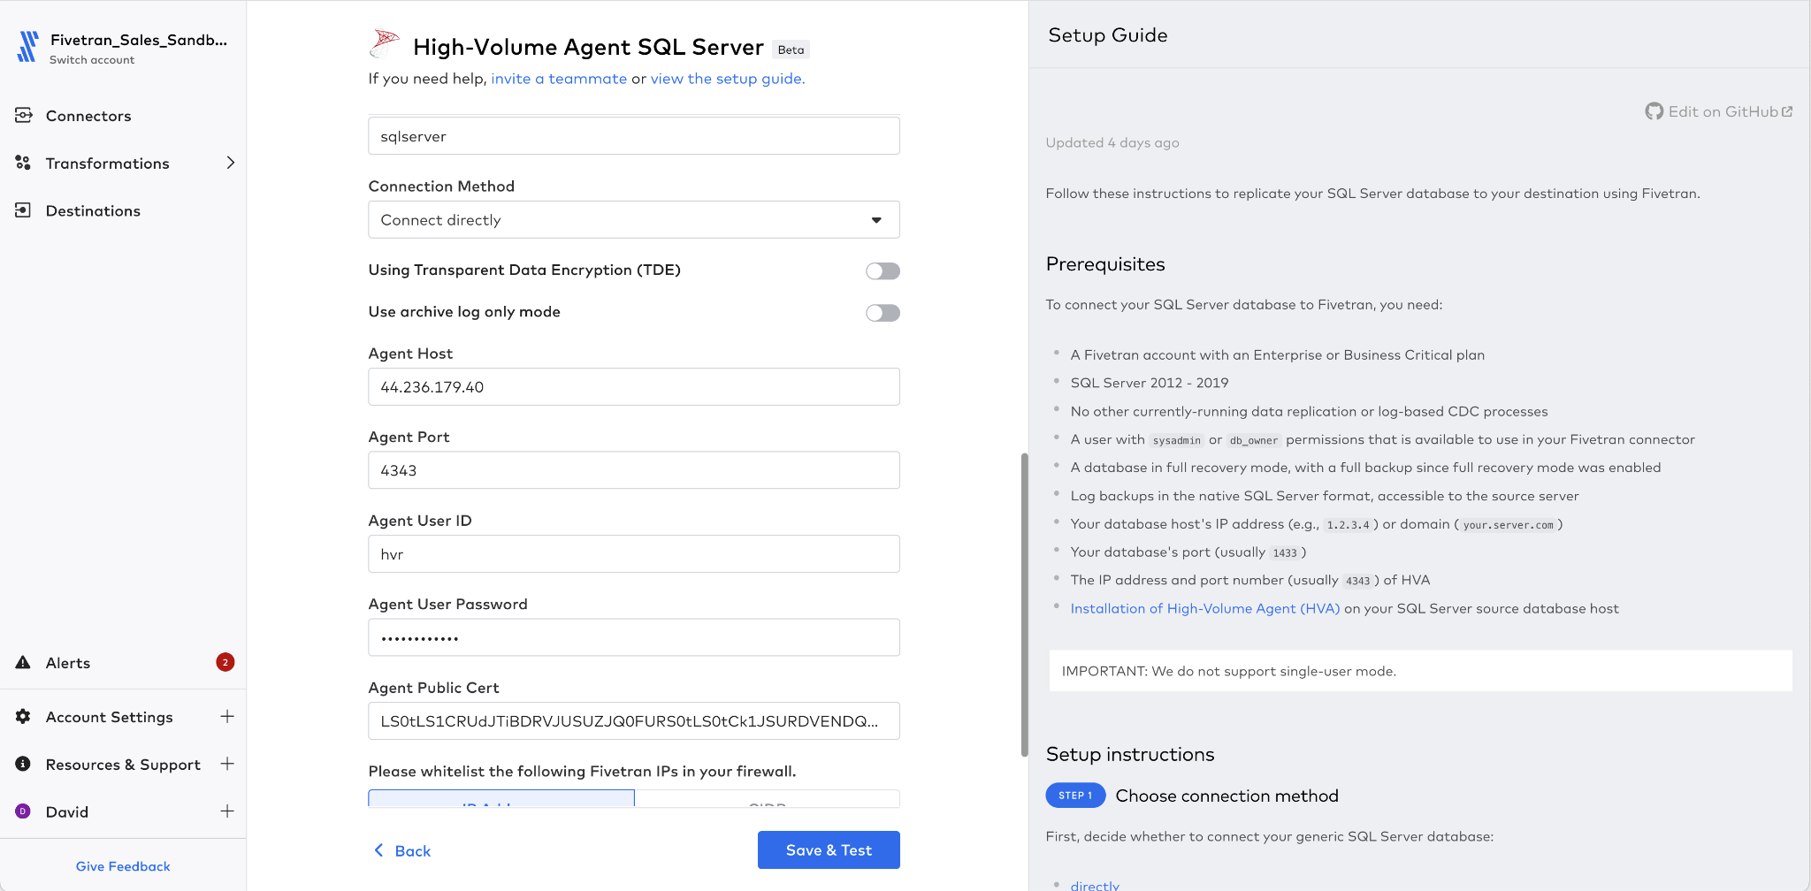

1. Click ‘Save & Test’.
2. Connection tests are run.

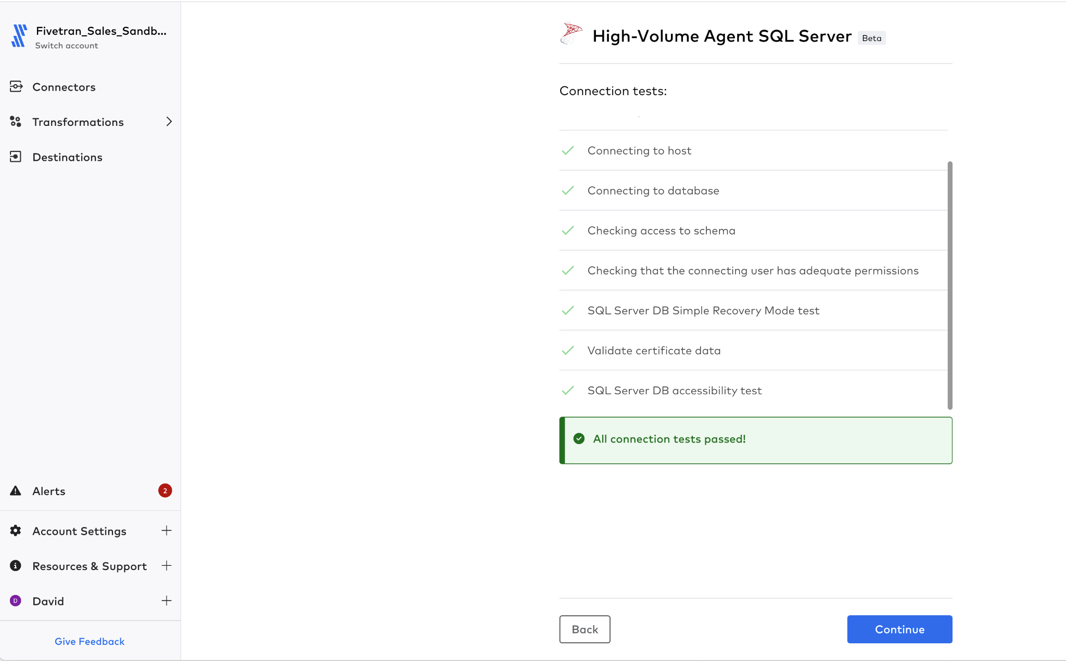

1. Select only the **animal_crossing** schema

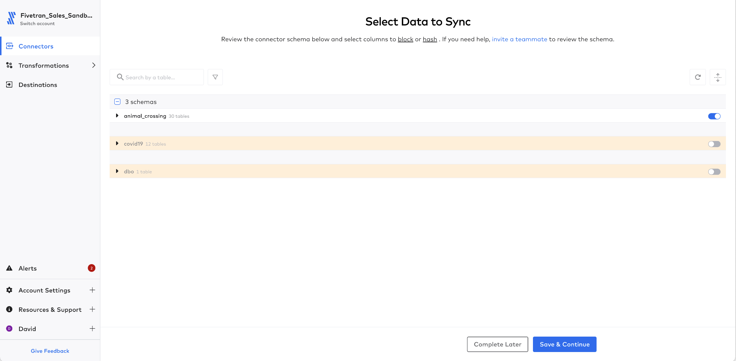

1. From the ‘animal_crossing’ schema, select only the ‘fish’ table.

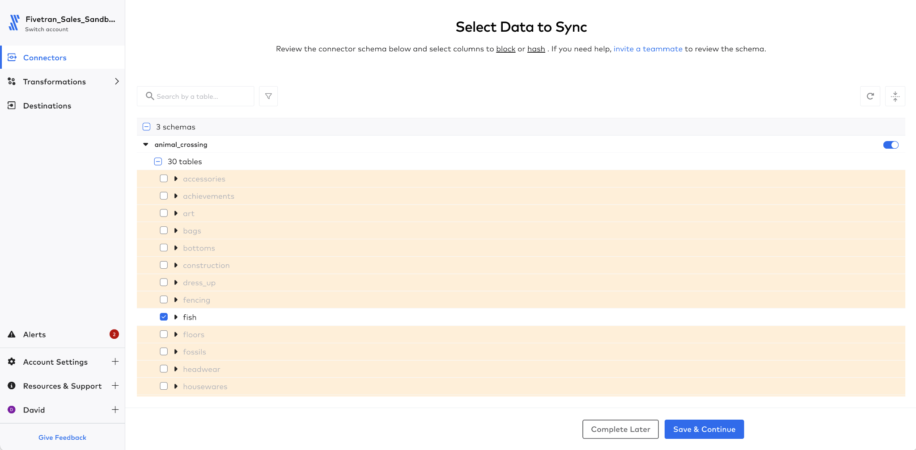

1. Click ‘Save & Continue’.
2. Select ‘Allow all’ on the schema changes dialog and click ‘Continue’.



1. Click ‘Start Initial Sync’.



1. Review the data in Snowflake.

**Congratulations you’ve successfully finished the HVA lab, the Certification is** [**HERE**](https://fivetran.zinfi.net/concierge/ucm/#/ucm/1298/1108/v/20) **Remember to have your copy of 100 Fivetran Facts close by**

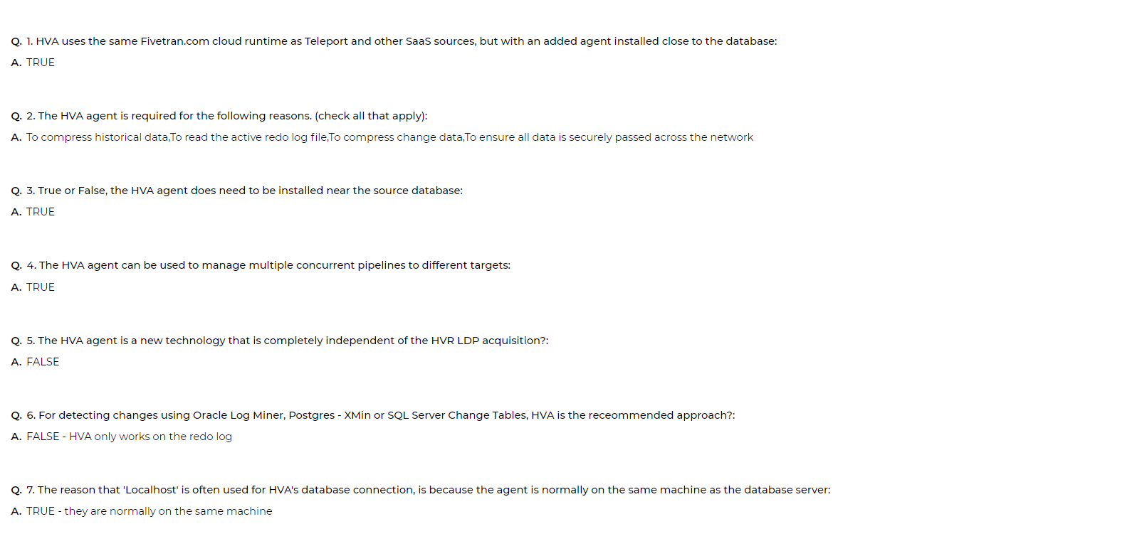

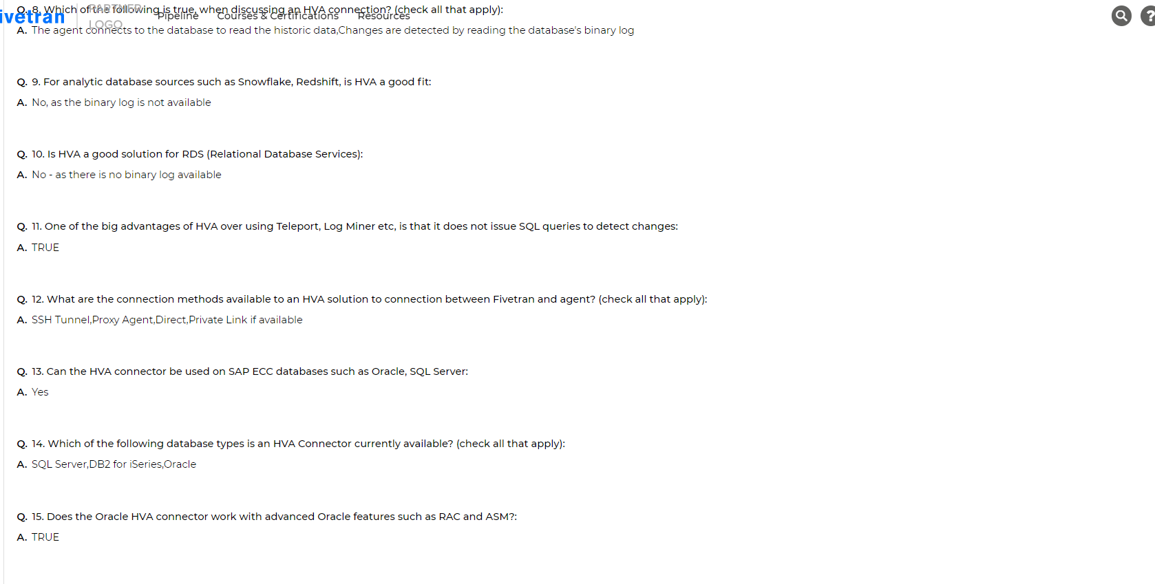

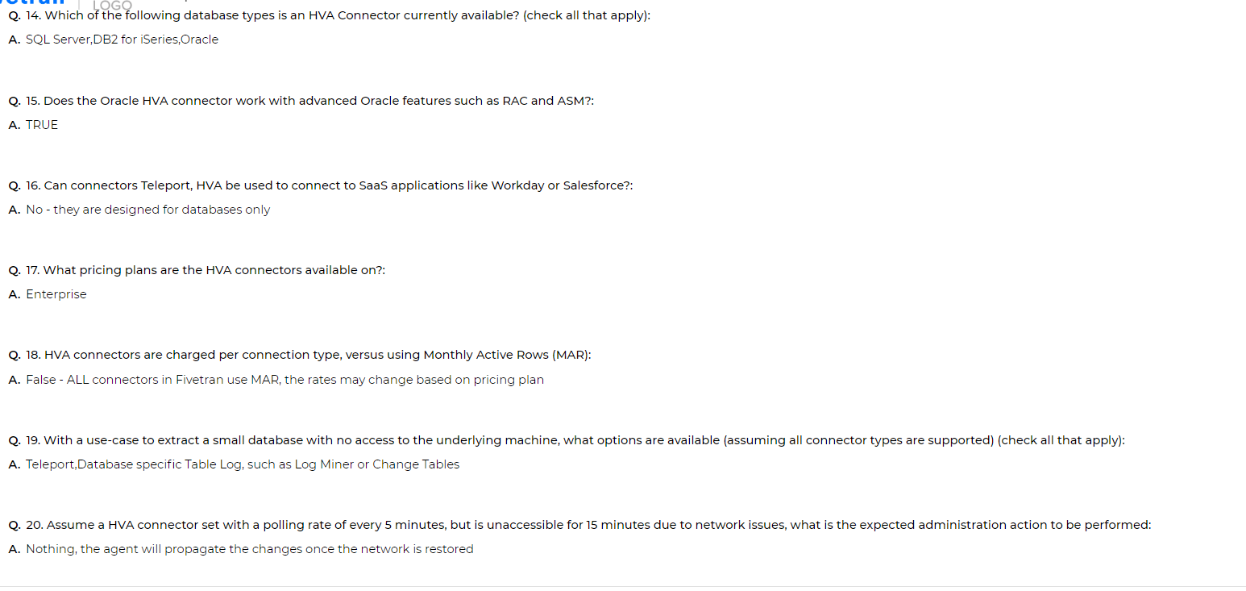

# APPENDIX - A - Lab 0 Files

This contains the structure and the contents of the S3 bucket ‘djmtestbucketv2’ that is blindly read as part of the file reading Lab 0.

All three files that are in the bucket can be found in the csv folder

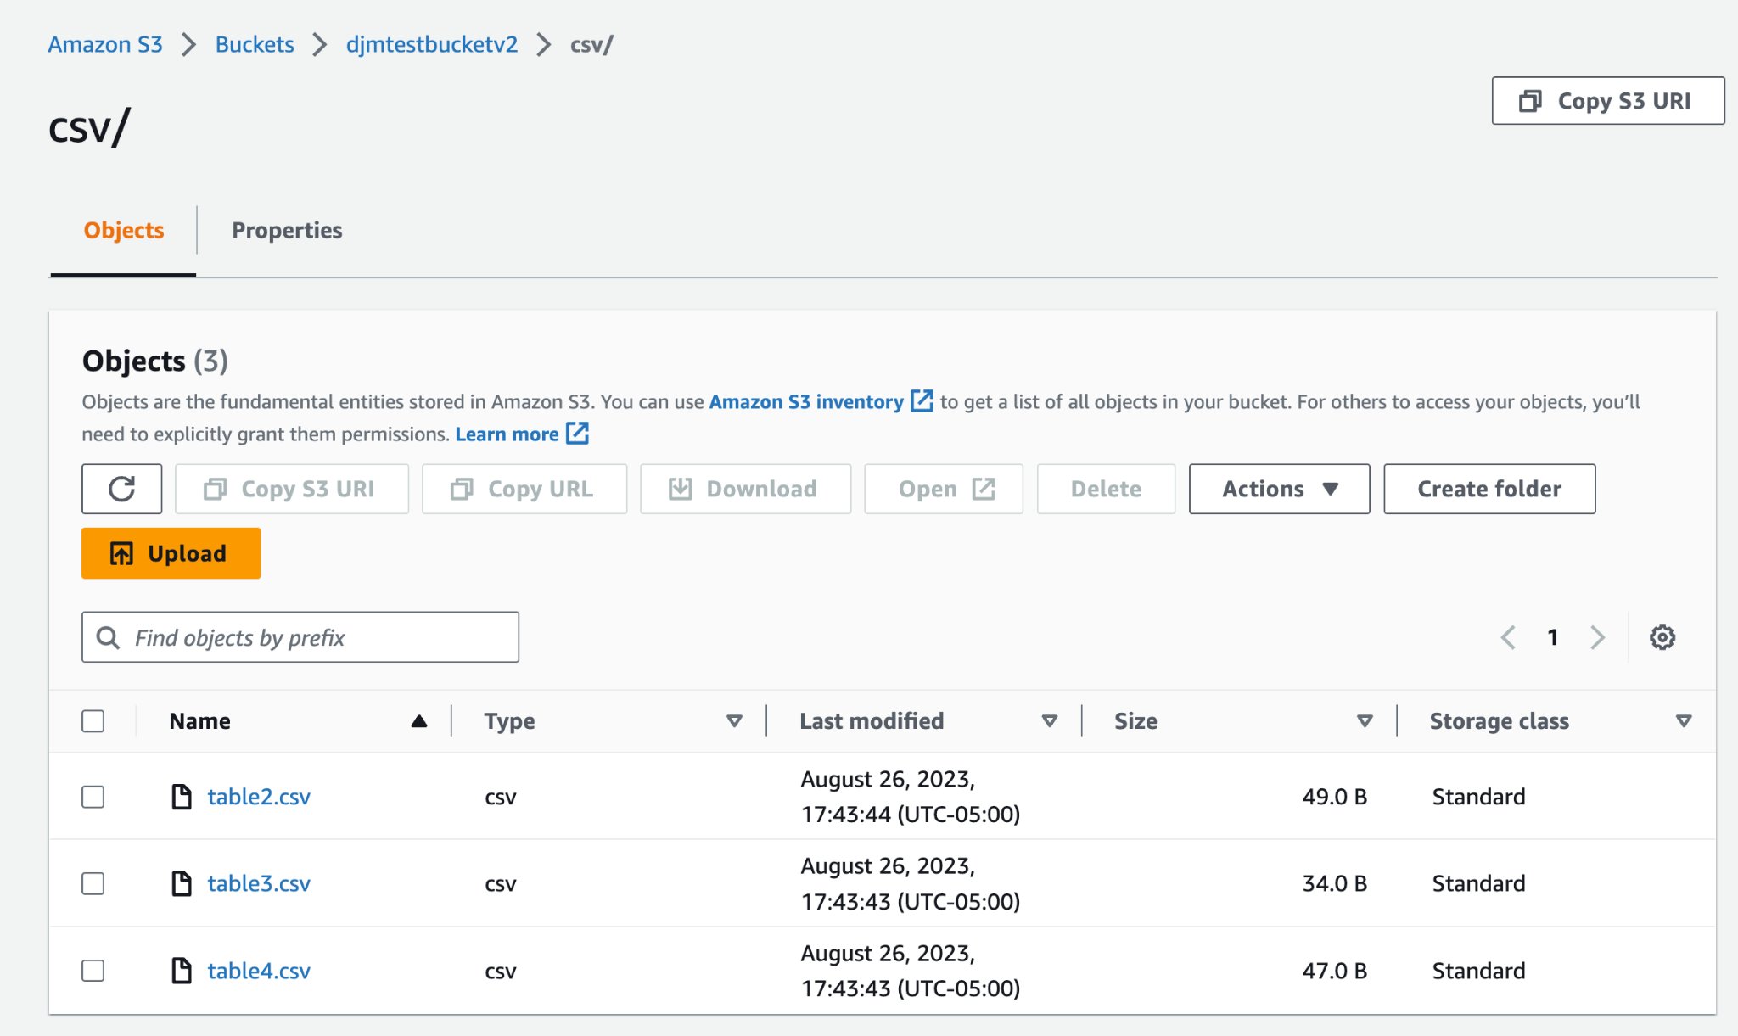  
The contents of each table is defined below and for each a list of actions demonstrating what is happening.

## Table2.csv

|  |
| --- |
| name,age,town,zip  1,2,3,4  10,23,fred,99  1,2,3,999 |

This is the first file to read, the target table is created with the columns ‘**name**’, ‘**age**’,’**town**’ and ‘**zip**’ as the first line is used to determine column names by default.

The first data line is read and all types will be determined to be numeric at first.

When the second line is read in, the town column is determined to be none numeric, it will therefore be converted to a text type.

When the third line is read in the value for town is a numeric value, but as this can be stored as a text, it will NOT change

## Table3.csv

|  |
| --- |
| col1,name,town,age  1,David,Lon,34 |

This table adds two new dimensions to the data. FIrstly col1 has been added and zip does not exist.

When the row is added, a new column ‘col1’ is added to the table. The value of zip is set to NULL and name is converted from an integer value to a text value as a change in datatype is needed to store the value ‘David’

## Table4.csv

|  |
| --- |
| newCol1,newCol2,newCol3,newCol4  1,David,Lon,34 |

Table4 simulates a completely different schema being read in the bucket.

The table will add four new columns, newCol1, newCol2, newCol3 and newCol4, of numeric, text, text and numeric types. These columns will be added to existing table

1. Excel files can only be imported from certain sources such as Google Drive etc, that support a mode called ‘Magic Mode’. [Here is a video example](https://www.youtube.com/watch?v=O2FtMS0BK0Q&list=PLf1ixTn00SJaCSoH6gVUJxtZtXKudgOTx&index=6&pp=iAQB)